﷽
Palestine Technical University - Kadoorie
College of Information Technology and Artificial Intelligence
Department of Information Systems - Information Security
Graduation Project:

PharmaSmart


Submitted By:
Obada Majdobi | 202212380
Qais Daraghmeh | 202211911
Hammam ShaikhIbrahim | 202213138

Supervisor:
Dr. Bashar Abu-Diak

Tulkarm - Palestine
2025-2026
Abstract

PharmaSmart is an innovative digital marketplace that connects customers with multiple pharmacies through a single, unified system.
The platform enables users to search for medicines and place orders directly with their preferred pharmacy.
By integrating pharmacies and customers in a single digital environment, the project aims to improve accessibility, transparency, and efficiency in the process of purchasing medicines.
PharmaSmart also supports pharmacies by helping them manage orders and expand their reach through online channels.
This project contributes to the digital transformation of the healthcare and pharmaceutical sectors, providing a convenient and reliable service for all parties involved.

Table of Contents
Table of Contents iii
List of Figures vi
List of Tables vii
1. Introduction 8
1.1 Introduction 9
1.2 Problem Statement 9
1.3 Project Objective 9
1.4 Project Benefits 10
1.5 Project Methodology 10
1.6 Research Plan 10
1.7 Project Constraints 12
1.8 Summary 12
2. System Analysis 13
2.1 Introduction 14
2.2 Related Works 14
2.3 Project Implementation Options 14
2.4 The Proposed System 15
2.5 System Requirements 15
2.5.1 Functional Requirements: 15
2.5.2 Non-Functional Requirements: 16
2.6 Feasibility Study 16
2.6.1 Economic feasibility 16
2.6.2 Technical feasibility 17
2.6.3 Legal feasibility 17
2.6.4 Schedule feasibility 17
2.7 Project Added Values 17
2.8 Project Management 17
2.9 Summary 18
3. System Functional Requirements 19
3.1 Introduction 20
3.2 Context 20
3.3 Use Case Diagrams 21
3.4 Functional requirements description 22
3.4.1 Registration 23
3.4.2 Log-in 23
3.4.3 Log-out 24
3.4.4 Manage Central Catalog 24
3.4.5 Manage Pharmacy Inventory 24
3.4.6 Search and Filter 25
3.4.7 Manage Cart 25
3.4.8 Submit Order & Upload Prescription 25
3.4.9 Process Orders (Accept, Reject, Deliver) 26
3.4.10 Manage Pharmacies Approval 26
3.5 Non-functional requirements description 26
3.5.1 Security: 26
3.5.2 Performance: 27
3.5.3 User Friendly: 27
3.5.4 Reliability: 27
3.6 Summary 27
4. System Design and Development 28
4.1 Introduction 29
4.2 Class Diagram 29
4.3 Sequence Diagram 30
4.3.1 Registration 30
4.3.2 Login 30
4.3.3 Search for Medicine 31
4.3.4 Place Order 32
4.3.5 Manage Inventory 33
4.3.6 Manage Orders 34
4.4 Entity Relationship Diagram (ER-model) 35
4.5 Activity Diagram 36
4.5.1 Patient Registration 36
4.5.2 Pharmacy Registration 37
4.5.3 Login 38
4.5.4 Purchasing Process 39
4.5.5 Pharmacist Order Handling 40
4.5.6 Inventory Management 41
4.6 System Interface 42
4.6.1 Patient Mobile Application (Flutter App) 42
4.6.2 PharmaSmart Webpage 60
4.7 Summary 70
5. Coding and Implementation 71
5.1 Introduction 72
5.2 Coding Programming Languages 72
5.3 Database System 72
5.4 Establishment of Development Environment 73
5.5 Stored Procedures and Transactional Logic 74
5.6 Summary and Recommendations 74
6. System Testing 76
6.1 Introduction 77
6.2 Specification Testing 77
6.3 Black Box Testing 77
6.4 White Box Testing 80
6.5 Regression Testing 80
6.6 Unit Testing 81
6.7 Summary and Recommendations 81
7. Conclusions and Future Works 82
7.1 Conclusions 83
7.2 Future Works 83

List of Figures
Figure ‎1.6.1 Research Plan Gantt Chart 11
Figure ‎1.6.2 Research Plan Gantt Chart 11
Figure ‎1.6.3 Research Plan Gantt Chart 12
Figure ‎3.2.1 Context Diagram 20
Figure ‎3.3.1 Use Case Diagram 22
Figure ‎4.3.1 Sequence Diagram - Registration 30
Figure ‎4.3.2 Sequence Diagram - Login 30
Figure ‎4.3.3 Sequence Diagram - Search for Medicine 31
Figure ‎4.3.4 Sequence Diagram - Place Order 32
Figure ‎4.3.5 Sequence Diagram - Manage Inventory 33
Figure ‎4.3.6 Sequence Diagram - Manage Orders 34
Figure ‎4.4.1 Entity Relationship Diagram 35
Figure ‎4.5.1 Activity Diagram - Patient Registration 36
Figure ‎4.5.2 Activity Diagram - Pharmacy Registration 37
Figure ‎4.5.3 Activity Diagram - Login 38
Figure ‎4.5.4 Activity Diagram - Purchasing Process 39
Figure ‎4.5.5 Activity Diagram - Pharmacist Order Handling 40
Figure ‎4.5.6 Activity Diagram - Inventory Management 41
Figure ‎4.6.1 Splash Screen 42
Figure ‎4.6.2 Onboarding Screen 1 43
Figure ‎4.6.3 Onboarding Screen 2 44
Figure ‎4.6.4 Onboarding Screen 3 45
Figure ‎4.6.5 Login Screen 46
Figure ‎4.6.6 Registration Screen 1 47
Figure ‎4.6.7 Registration Screen 2 48
Figure ‎4.6.8 Main Screen 49
Figure ‎4.6.9 Pharmacies Screen 50
Figure ‎4.6.10 Pharmacy Details Screen 51
Figure ‎4.6.11 Pharmacy Store Screen 52
Figure ‎4.6.12 Notification Screen 53
Figure ‎4.6.13 My Orders Screen 54
Figure ‎4.6.14 Medicine Details Screen 55
Figure ‎4.6.15 Cart Screen 1 56
Figure ‎4.6.16 My Cart Screen 2 57
Figure ‎4.6.17 Profile Screen 1 58
Figure ‎4.6.18 Profile Screen 2 59
Figure ‎4.6.19 Webpage Login Screen 60
Figure ‎4.6.20 Webpage Registration Screen 61
Figure ‎4.6.21 Admin Dashboard Screen 62
Figure ‎4.6.22 Admin Pharmacies Management Screen 63
Figure ‎4.6.23 Admin Patients Management Screen 64
Figure ‎4.6.24 Pharmacist Dashboard Screen 65
Figure ‎4.6.25 2 Pharmacist Medicine Screen 66
Figure ‎4.6.26 Add Medicine Screen 67
Figure ‎4.6.27 Order Screen 68
Figure ‎4.6.28 Order Details Screen 69

List of Tables
Table ‎3.4.1 Functional requirements description Registration 23
Table ‎3.4.2 Functional requirements description Log-in 23
Table ‎3.4.3 Functional requirements description Log-out 24
Table ‎3.4.4 Functional requirements description Manage Central Catalog 24
Table ‎3.4.5 Functional requirements description Manage Pharmacy Inventory 24
Table ‎3.4.6 Functional requirements description Search and Filter 25
Table ‎3.4.7 Functional requirements description Manage Cart 25
Table ‎3.4.8 Functional requirements description Submit Order & Upload Prescription 25
Table ‎3.4.9 Functional requirements description Process Orders (Accept, Reject, Deliver) 26
Table ‎3.4.10 Functional requirements description Manage Pharmacies Approval 26
Table ‎6.3.1 User Authentication (Login) Test Cases 78
Table ‎6.3.2 Patient Registration (Sign-up) Test Cases 78
Table ‎6.3.3 Shopping Cart & Checkout Test Cases 79
Table ‎6.4.1 Database Transactions and Order Processing 80

Chapter 1

Introduction

Introduction
PharmaSmart is an innovative digital marketplace that connects customers with multiple pharmacies through a single, unified system. The platform enables users to search for medicines, view real-time inventory, and place orders directly with their preferred pharmacy.
Built with a modern technological stack, the system offers a mobile application for patients and a responsive web dashboard for pharmacists and administrators. It integrates advanced user experience (UX) features, including Localization (Arabic/English support), Dark/Light Mode, and Interactive Maps (Leaflet.js) for precise location tracking. By integrating pharmacies and customers in a single digital environment, the project aims to improve accessibility, transparency, and efficiency in the process of purchasing medicines.

Problem Statement
In many areas, people still face difficulties in finding certain medicines.
A customer may visit several pharmacies to locate a single item, and even then, there is no guarantee that any of them have the drug in stock.
This process is time-consuming and inefficient, especially for patients with chronic conditions or those who rely on regular prescriptions.
On the other hand, pharmacies often lack digital tools to manage online requests or expand their customer base.
PharmaSmart was created to address these challenges by providing a single digital platform where users can search for and order medicines directly.

Project Objective
The main objectives of PharmaSmart are:
- To develop a user-friendly mobile and web application for searching and ordering medicines.
- To provide real-time information about product availability and pricing across multiple pharmacies.
- To offer pharmacy owners an easy-to-use control panel for managing products and orders.
- To build a secure system that protects users’ data and ensures safe communication between customers and pharmacies.
- To support digital transformation in the local healthcare sector by improving service accessibility.
- To implement a Centralized Medicine Catalog, managed exclusively by administrators, ensuring data consistency and preventing duplicate medication entries across different pharmacies.
- To enforce a strict Prescription Verification Protocol (Rx) for controlled medications, ensuring that such drugs are only dispensed after pharmacist validation.

Project Benefits
- For customers:
PharmaSmart saves time by allowing users to check medicine availability and prices without leaving home. It also makes purchasing easier and more transparent.
- For pharmacies:
It provides an online presence and expands their customer reach. Additionally, it offers a smart dashboard that calculates Profit Margins dynamically and provides automated alerts for Low Stock and Nearing Expiry Dates, enabling highly effective inventory management.
- For the community:
The project promotes digital progress in healthcare and reduces effort for both patients and pharmacy staff.

Project Methodology
The project follows the Incremental–Agile methodology, as it best suits small to medium interactive systems like PharmaSmart.
Incremental development allows the system to be built in several functional parts, where each part adds new features that can be tested and improved.
Combining this with Agile practices ensures flexibility, faster feedback, and continuous improvement throughout the development process.
This approach helps deliver a working version early, allows for easy adaptation to changes, and gradually evolves the project into a complete, stable product.

Research Plan
The following figures present the Work Breakdown Structure (WBS) for the PharmaSmart project, detailing the scope of work and key deliverables.
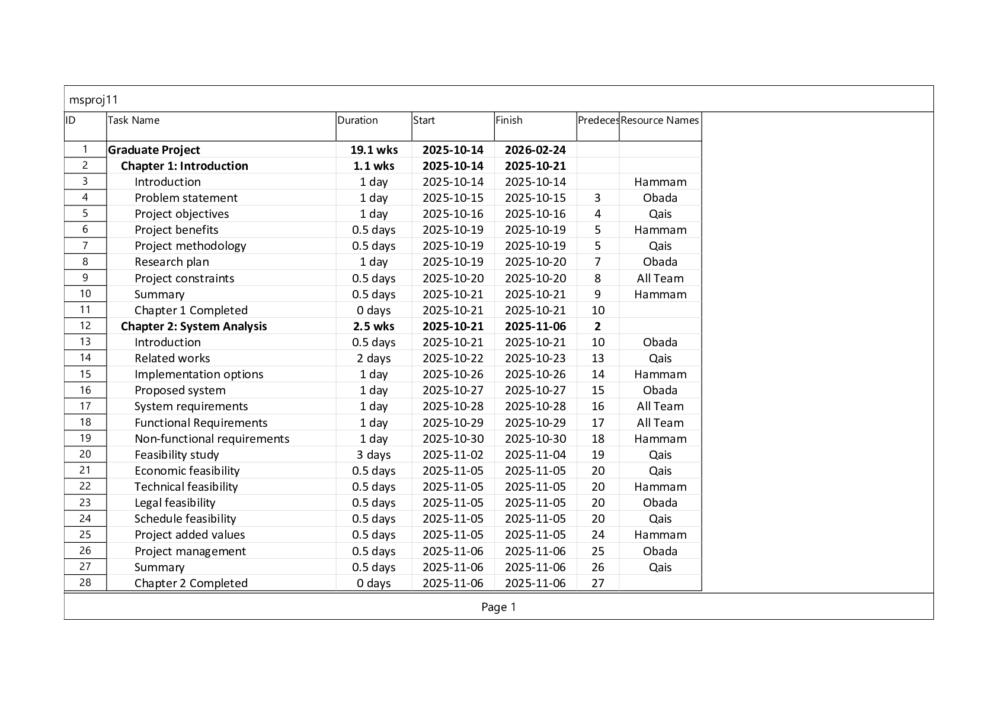
Figure ‎1.6.1 Research Plan Gantt Chart
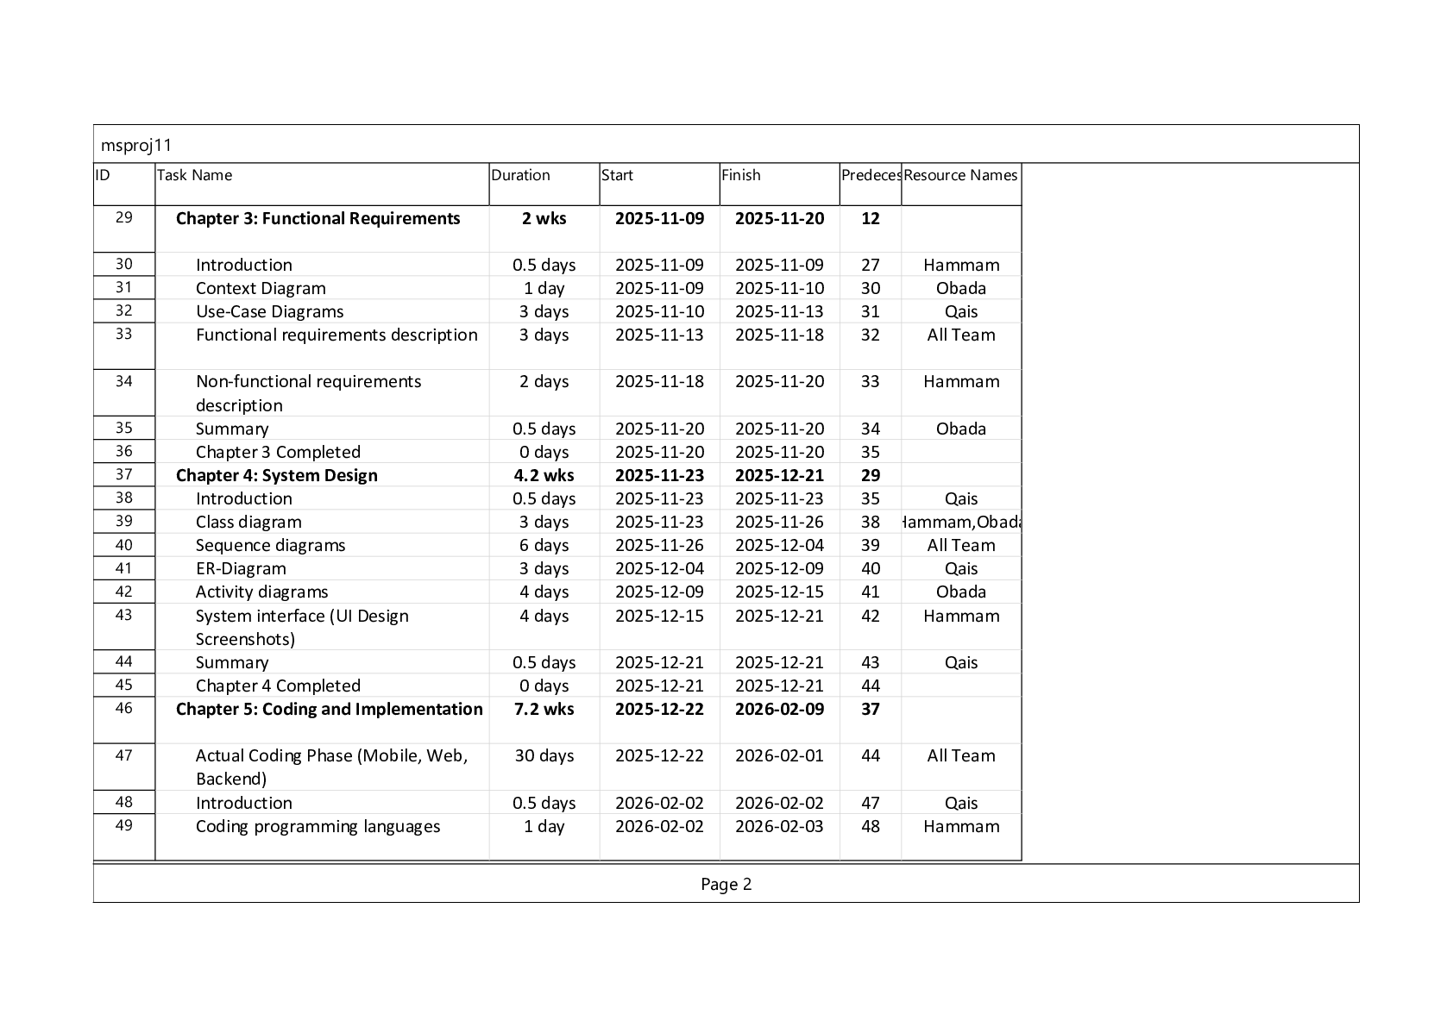
Figure ‎1.6.2 Research Plan Gantt Chart
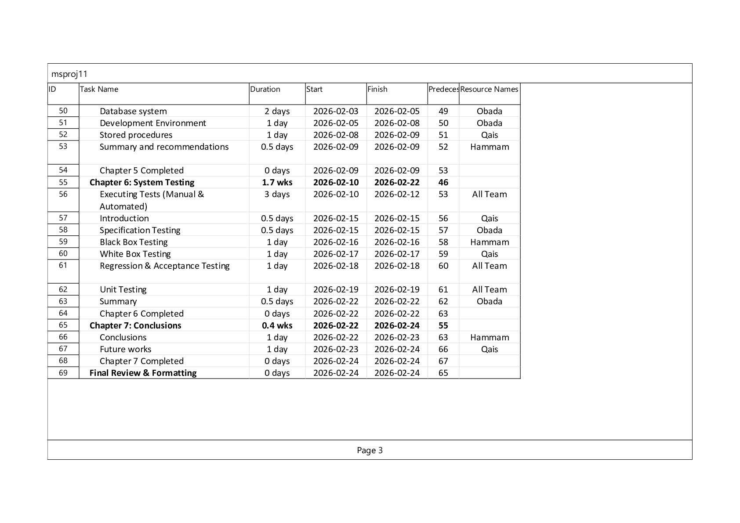
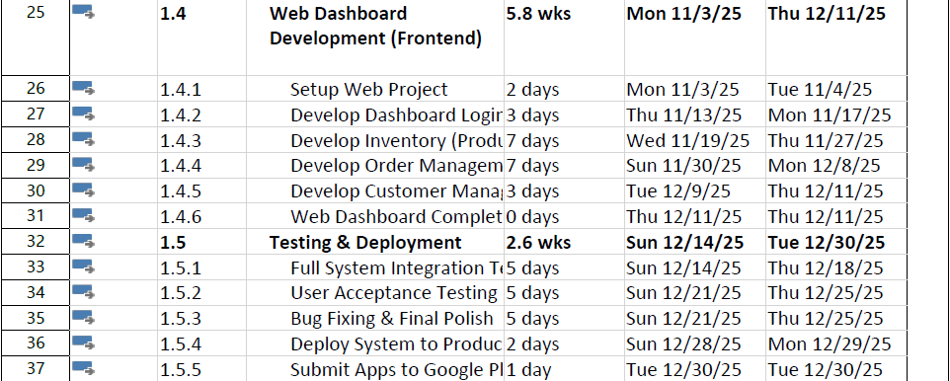
Figure ‎1.6.3 Research Plan Gantt Chart

Project Constraints
Every project has its challenges and limitations. For PharmaSmart, these include:
- Time:
A limited timeframe for development and testing, estimated at approximately two semesters (14 weeks).
Due to the strict timeframe, certain advanced modules, such as the real-time chat system and medication reminder alarms, were deferred to future development phases to focus on perfecting the core e-commerce and inventory functionalities.
- Scope:
Small team size and limited resources.
- Resources:
Using sample data instead of real pharmacy records in the early phase.

Summary
PharmaSmart offers a straightforward yet effective solution for connecting customers and pharmacies on a single digital platform.
It reduces the difficulty of finding medicines and supports pharmacies in digitalizing their service.
Chapter 2

System Analysis

Introduction
In this chapter, we will include an example relevant to our project and discuss the implementation options for developing our project, including our proposed system, its distinguishing features, and a comparison with the system we previously mentioned.
We will also cover the functional and non-functional requirements. Furthermore, we will conduct a general feasibility study, followed by an economic, legal, and time-related analysis. Finally, we will outline the added value to the project and discuss project management methods, providing a summary of this section.

Related Works
The concept of online marketplaces has been successfully implemented across various sectors. Platforms like Haat and Mart.ps have revolutionized the food delivery and retail industries, respectively, by connecting customers with a wide range of vendors through centralized digital platforms. Their success is built on providing convenience, variety, and an efficient ordering and delivery process.
In the pharmaceutical sector, there are also online pharmacy forms. I couldn't find what a local app was, but Chefaa, for example, is a pharmacy delivery app that connects users to local pharmacies in Egypt and Saudi Arabia. While existing systems offer online ordering, few provide a comprehensive, patient-centered ecosystem that integrates medication reminders, online consultations with pharmacists, and a multi-vendor marketplace model specifically designed to empower local pharmacies.
PharmaSmart differentiates itself not only as a sales channel but also as a comprehensive health management tool.

Project Implementation Options
To develop the PharmaSmart system, several technology stacks were considered. The final decision was based on scalability, development speed, and the specific requirements of each system component.
- Mobile Application (Client-side):
Options included native development and cross-platform frameworks. Flutter was chosen for its ability to create a high-performance, natively compiled application for both Android and iOS from a single codebase, ensuring a consistent user experience.
- Web Dashboard (Pharmacy & Admin):
Standard web development technologies were evaluated. The project utilizes a powerful combination of PHP (Native) and MySQL for backend logic, integrated with AJAX for seamless, real-time data fetching without page reloads. The frontend is styled using Tailwind CSS for modern, responsive design, alongside SweetAlert2 for interactive notifications and Leaflet.js for geographic mapping.
- Backend and Database:
PHP was chosen for its robustness, extensive support, and seamless integration with the MySQL database, which was chosen for its reliability and efficiency in handling relational data for products, users, and orders.

The Proposed System
PharmaSmart is a comprehensive e-commerce marketplace connecting patients with local pharmacies. The system comprises three main components: a customer-facing mobile application, a web-based dashboard for pharmacies, and an administrative panel for system oversight.
Unlike traditional online pharmacies that operate from a central warehouse, PharmaSmart empowers local pharmacies by providing them with a digital storefront.
A key feature of the proposed system is the Centralized Catalog Architecture. Unlike traditional systems where each pharmacist manually types drug details, PharmaSmart provides a unified database managed by administrators. Pharmacists simply select medications from this catalog, assign their quantities, and set competitive prices.
Furthermore, the system includes a Single-Pharmacy Cart Constraint, ensuring that patients order from one pharmacy at a time to streamline delivery. It also enforces a mandatory prescription upload and verification protocol for controlled drugs (Rx), ensuring legal and medical compliance before any order is accepted.

System Requirements
The requirements for the PharmaSmart system are divided into functional and non-functional categories to ensure all aspects of the system's behavior and quality are addressed.

Functional Requirements:
- Allow users (Patients, Pharmacists, and Administrators) to securely log into their respective accounts using their credentials.
- Require new patients and pharmacies to select their exact geographical coordinates (Latitude and Longitude) via an interactive map during the registration process.
- Enable administrators to manage a centralized catalog of medicines, specifying scientific names, categories, and controlled (Rx) status to prevent duplicate entries.
- Allow pharmacists to add medicines from the centralized catalog to their pharmacy’s inventory, define selling prices, and specify available stock quantities.
- Generate automated system alerts for pharmacists to notify them about low-stock items and medications nearing their expiry dates.
- Provide patients with a real-time search engine to discover medicines and filter nearby pharmacies based on distance and price.
- Restrict patients' shopping carts to accept items from only a single pharmacy per order to streamline the delivery process.
- Enforce the mandatory upload of a clear medical prescription image by the patient if the selected cart contains any controlled (Rx) medications.
- Enable pharmacists to accept, deliver, or reject incoming orders, while requiring them to input a mandatory textual reason if an order is rejected.
- Display a live interactive map on the administrator dashboard illustrating the geographic distribution of active and pending pharmacies for approval purposes.

Non-Functional Requirements:
The non-functional requirements define the system's quality attributes and constraints. For the PharmaSmart platform, these include:
- Security:
Protecting user credentials and preventing unauthorized access based on user roles.
- Performance:
Ensuring fast response times and seamless data loading without interrupting the user experience.
- Usability:
Providing an intuitive, customizable, and bilingual interface suitable for all user levels.
- Reliability & Data Integrity:
Ensuring consistent database operations and preventing data loss or corruption during critical transactions.

Feasibility Study

Economic feasibility
The development of the PharmaSmart platform is considered economically feasible. Initial development costs can be managed by building a Minimum Viable Product with core features, estimated to be between $100 and $500.
Revenue can be generated through a commission-based model on orders processed through the platform, similar to other marketplace applications. The potential for growth and increasing demand for online pharmaceutical services suggest a strong return on investment.

Technical feasibility
The project is technically feasible. The chosen technology stack, including Flutter for the mobile app and PHP/MySQL for the backend, consists of mature and well-supported technologies. There are ample developer resources and documentation available. The development team possesses the necessary skills to implement the required features and integrations.

Legal feasibility
The online sale of pharmaceuticals is subject to strict regulations. The project must ensure compliance with local and international laws regarding the dispensing of prescription medications and the protection of patient health information.

Schedule feasibility
The project can be realistically completed within a defined timeframe. By adopting an agile development methodology, the project will be broken down into manageable sprints.
An initial Minimum Viable Product can be developed within a 14-week period, with subsequent iterations adding more advanced features.
This iterative approach allows for flexibility and ensures that a functional product is delivered in a timely manner.

Project Added Values
PharmaSmart offers significant value to both patients and pharmacies:
For Patients: Provides a convenient and accessible way to obtain medication, enhances medication adherence through smart reminders, and offers direct access to professional pharmaceutical advice.
For Pharmacies: Offers a low-cost entry into the e-commerce space, expands their customer reach, and provides digital tools to streamline order and inventory management.
For the Community: Promotes better health outcomes through improved medication management and supports local businesses by integrating community pharmacies into the digital economy.

Project Management
Developers of this project:
- Hammam Ibrahim
- Obada Majdobi
- Qais Daraghmeh
Group leader Hammam Ibrahim divided the tasks by dividing the A chapter among all team members within the period specified for Its implementation: Compile and deliver this work.

Summary
The second chapter of this report covers various aspects related to the proposed project. It begins by reviewing related works and discussing different options for implementing the project. The proposed system is introduced, and its requirements are clarified. The chapter also includes a feasibility study that covers economic, technical, legal, and time-related aspects. Furthermore, it highlights the value of the project.

Chapter 3

System Functional Requirements

Introduction
System requirements are crucial elements in the development of any software, delineating the functionalities and characteristics necessary for its successful operation. In this chapter, the functional requirements of the PharmaSmart system are detailed. It provides a visual representation through the Use-Case Diagram showing the interaction between the system actors (Admin, Pharmacist, Patient) and the system functionalities. Furthermore, it describes these functional requirements in detail using structured tables.

Context
The Context Diagram represents the system as a single process interacting with external entities. For PharmaSmart:
- The System: PharmaSmart Platform.
- External Entities:
  - Patient: Sends orders, prescriptions, chat messages; receives notifications and order status.
  - Pharmacist: Sends inventory updates, order status updates; receives new orders and chat messages.
  - Admin: Sends system configurations and approvals; receives reports and registration requests.
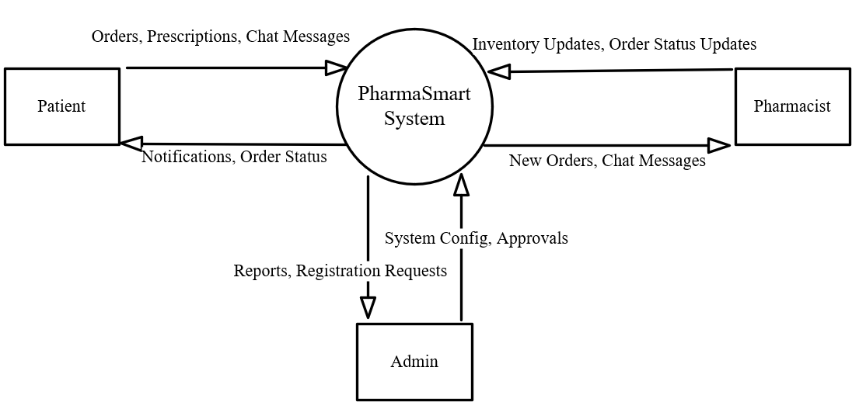
Figure ‎3.2.1 Context Diagram

Use Case Diagrams
The Use Case diagram illustrates the relationships between the actors (Patient, Pharmacist, Admin) and the functional requirements (Use Cases) within the system.
Actors:
- Patient (Client): Mobile App User.
- Pharmacist (Pharmacy Manager): Web Dashboard User.
- Admin: System Administrator.
Main Use Cases:
- Registration
- Log-in
- Log-out
- Search and Filter
- Submit Order
- Process Orders
- Manage Cart
- Manage Pharmacy Inventory
- Manage Central Catalog
- Manage Pharmacies Approval
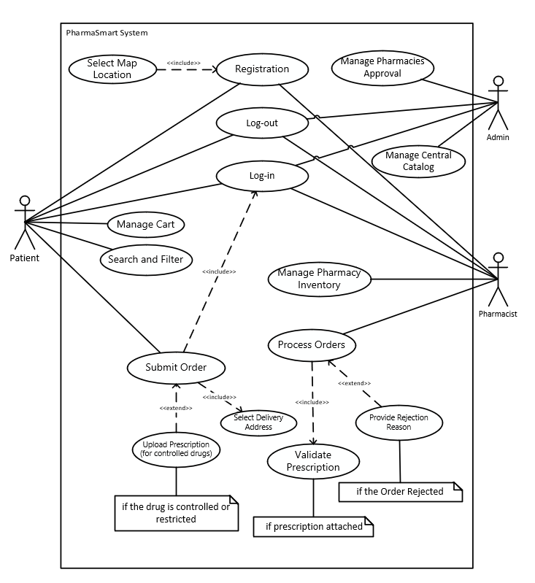
Figure ‎3.3.1 Use Case Diagram

Functional requirements description
The following tables describe the functional requirements in detail, defining the inputs, processes, and outputs for each function.

3.4.1 Registration
Description | Users (Patients) and Pharmacists create an account on PharmaSmart.
Actor | Patient, Pharmacist.
Input | First Name, Last Name, Email, Password, Phone, Medical History (for patient), License Number and Working Hours (for pharmacist), and GPS Location (Lat/Long).
Process | The system captures the inputs, validates the map coordinates using Leaflet.js, hashes the password, and creates a new record in the database.
Output | Account is successfully created (Pharmacist account is set to "Pending" until Admin approval).
Table ‎3.4.1 Functional requirements description Registration

Log-in
Description | Registered users access their personalized dashboards or application interfaces.
Actor | Patient, Pharmacist, Admin.
Input | Email and Password.
Process | The system verifies the credentials against the database. It checks the RoleID and redirects the user to the appropriate interface (Mobile app for patients, Web dashboard for pharmacists & admins). It blocks access for "Pending" pharmacists.
Output | User successfully logs in and views their specific dashboard, or receives an error message.
Table ‎3.4.2 Functional requirements description Log-in

3.4.3 Log-out
Description | Users securely end their current session.
Actor | Patient, Pharmacist, Admin.
Input | Click on the logout button.
Process | The system securely destroys the active session and clears authentication cookies.
Output | The user is redirected to the login screen.
Table ‎3.4.3 Functional requirements description Log-out

Manage Central Catalog
Description | Administrator manages the core database of medications to prevent duplicate data entry by pharmacists.
Actor | Admin.
Input | Medicine Name, Scientific Name, Description, Image, Fixed Cost Price, Category, and "Is Controlled (Rx)" flag.
Process | The admin inserts, updates, or deletes records within the SystemMedicine table.
Output | The catalog is updated and globally available for all pharmacists.
Table ‎3.4.4 Functional requirements description Manage Central Catalog

3.4.5 Manage Pharmacy Inventory
Description | Pharmacists add medications from the central catalog to their specific pharmacy stock.
Actor | Pharmacist.
Input | Selected Medicine (from catalog), Selling Price, Stock Quantity, Minimum Stock Limit, and Expiry Date.
Process | The system links the medicine to the pharmacy (PharmacyStock table), dynamically calculates the profit margin, and initializes expiry and low-stock alerts.
Output | The medication becomes visible to patients searching nearby this specific pharmacy.
Table ‎3.4.5 Functional requirements description Manage Pharmacy Inventory

3.4.6 Search and Filter
Description | Patients search for specific medications and view pharmacies that have them in stock.
Actor | Patient.
Input | Keyword (Trade/Scientific name), Category, Sort by (Price or Distance).
Process | The system performs an asynchronous AJAX search, queries the inventory, calculates the distance between the patient's GPS coordinates and the pharmacy, and filters the results.
Output | Real-time display of available medicines including price, remaining stock, and distance in km.
Table ‎3.4.6 Functional requirements description Search and Filter

3.4.7 Manage Cart
Description | Patients add, update, or remove selected medications in their shopping cart.
Actor | Patient.
Input | Add/Remove item, Adjust quantity.
Process | The system calculates the total price and enforces a "Single Pharmacy Constraint" (patients cannot add medicines from different pharmacies in the same order).
Output | The cart total is updated or an alert is shown if mixing pharmacies is attempted.
Table ‎3.4.7 Functional requirements description Manage Cart

3.4.8 Submit Order & Upload Prescription
Description | Patients finalize their cart and submit the delivery order.
Actor | Patient.
Input | Delivery Address, Custom GPS Location, Payment Method (COD), and Prescription Image (if required).
Process | The system verifies if any item in the cart has the IsControlled flag. If true, it forces the user to upload a prescription image. The order details are then saved in the database.
Output | Order status is set to "Pending" and a notification is sent to the pharmacist.
Table ‎3.4.8 Functional requirements description Submit Order & Upload Prescription

3.4.9 Process Orders (Accept, Reject, Deliver)
Description | Pharmacists manage incoming orders from patients.
Actor | Pharmacist.
Input | Action selection, Rx verification checkbox, Rejection Reason text.
Process | The system mandates checking the Rx verification box for controlled drugs. If rejecting, it requires a textual reason (RejectionReason). If marking as delivered, it automatically deducts the quantities from PharmacyStock.
Output | Order status is updated, stock is adjusted, and the patient is informed of the outcome.
Table ‎3.4.9 Functional requirements description Process Orders (Accept, Reject, Deliver)

Manage Pharmacies Approval
Description | Administrators monitor and approve/suspend pharmacies joining the platform.
Actor | Admin.
Input | Action (Approve / Suspend).
Process | The admin views a live interactive map showing active (Green) and pending (Orange) pharmacies, and modifies their IsApproved status in the database.
Output | Pharmacy account is activated or suspended.
Table ‎3.4.10 Functional requirements description Manage Pharmacies Approval

Non-functional requirements description

3.5.1 Security:
- Password Hashing:
The system ensures that all user passwords are encrypted before storage using the robust password_hash () algorithm in PHP, preventing plain-text password leaks.
- Role-Based Access Control (RBAC):
The system strictly validates user roles (RoleID). For example, patients are technically blocked from accessing the web dashboard, and unapproved pharmacies are restricted from managing orders until admin activation.
- SQL Injection Prevention:
All user inputs are sanitized using mysqli_real_escape_string to protect the database from malicious queries

3.5.2 Performance:
- Asynchronous Processing (AJAX):
The web dashboard utilizes AJAX for live searching (e.g., searching for medicines or filtering order statuses). This allows the system to fetch and display data instantly without reloading the entire page, significantly reducing server load

3.5.3 User Friendly:
- Theme Customization:
The system features a built-in toggle for Dark and Light modes (saved via local storage and cookies) to reduce eye strain and provide a modern aesthetic.
- Localization:
The platform supports bilingual interfaces (Arabic and English) managed dynamically through a centralized dictionary file (lang.php), enhancing accessibility for local users.
- Interactive Feedback:
The system replaces standard browser alerts with visually appealing pop-ups using the SweetAlert2 library, providing clear success, error, and warning messages to the users.

3.5.4 Reliability:
- Database Transactions:
Critical processes, such as Registration and Order Placement, are executed
using SQL Transactions (Commit and Rollback). This ensures that if an error occurs halfway through (e.g., failing to save a pharmacy's location after saving the user data), the entire operation is reversed to prevent corrupted or orphaned data.
- Relational Constraints:
The database utilizes Foreign Keys with ON DELETE CASCADE rules, ensuring that if a pharmacy or a patient account is deleted, all their associated stock and orders are consistently removed to maintain system stability.

Summary
This chapter discussed the system analysis by detailing the Use-Case Diagrams and describing the Functional Requirements through structured tables. It also highlighted the Non-Functional Requirements such as security, performance, and usability, which are essential for the successful implementation of the PharmaSmart project. The next chapter will cover the System Design and Development.

Chapter 4

4. System Design and Development

Introduction
Chapter 3 presented the functional requirements of the system and illustrated them using the Use Case diagram. This chapter focuses on the system design of the PharmaSmart project and presents the main UML diagrams, including Class, Sequence, Entity Relationship (ER), and Activity diagrams.

Class Diagram
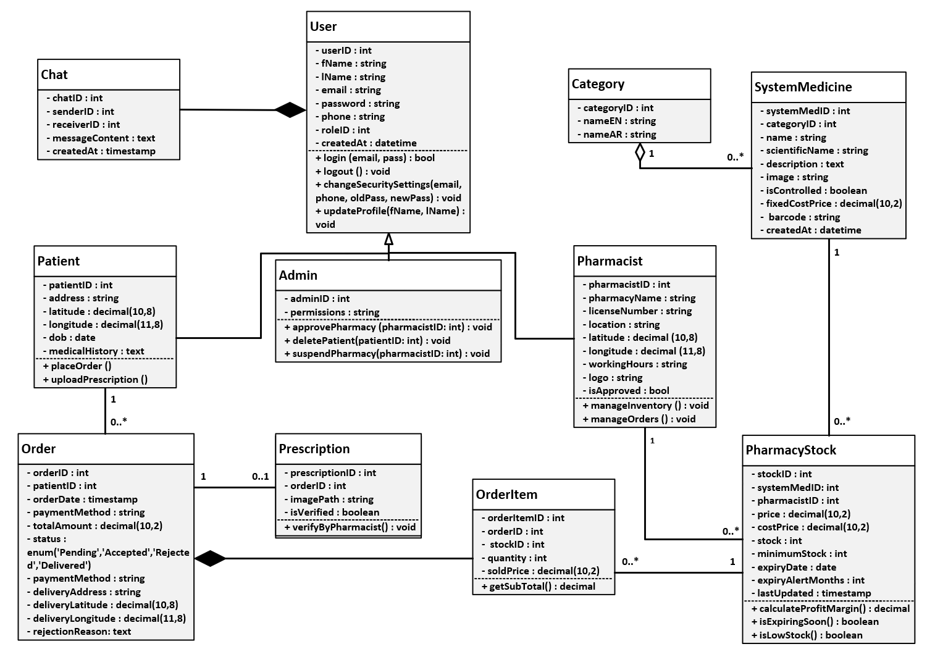
The Class Diagram represents the static structure of the PharmaSmart system. It describes the system's classes, their attributes, methods, and the relationships between objects. This diagram is strictly based on the centralized catalog architecture, where medications are managed globally and then linked to specific pharmacy stocks.
Figure ‎4.2.1 Class Diagram

Sequence Diagram

Registration
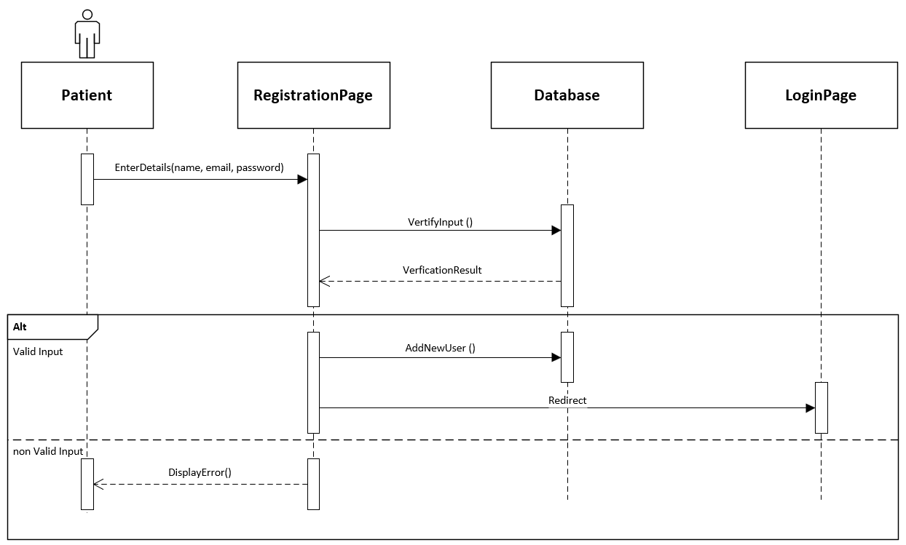
Figure ‎4.3.1 Sequence Diagram - Registration

Login
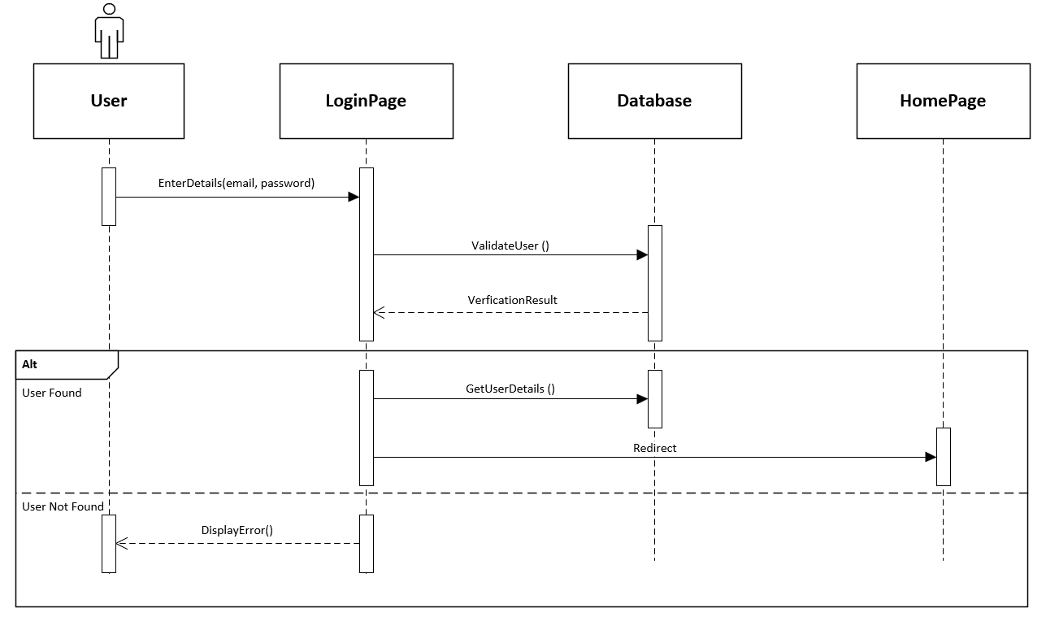
Figure ‎4.3.2 Sequence Diagram - Login

Search for Medicine
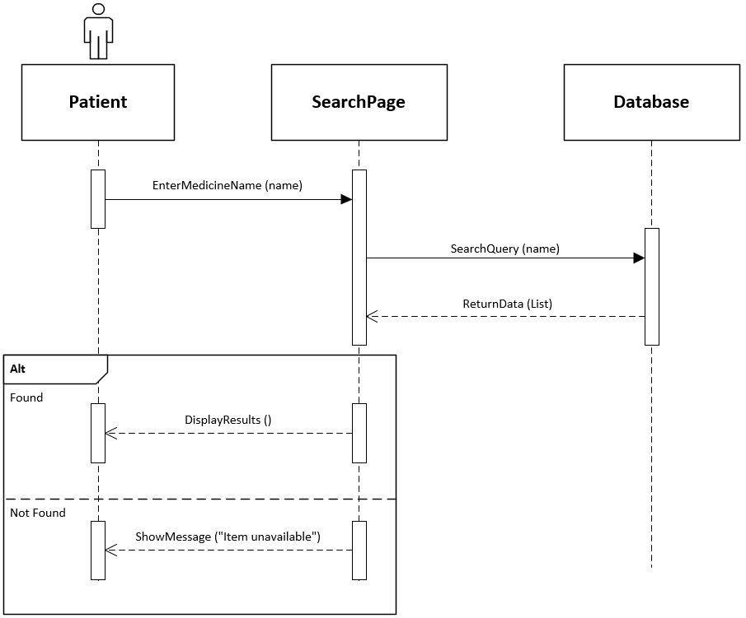
Figure ‎4.3.3 Sequence Diagram - Search for Medicine

Place Order
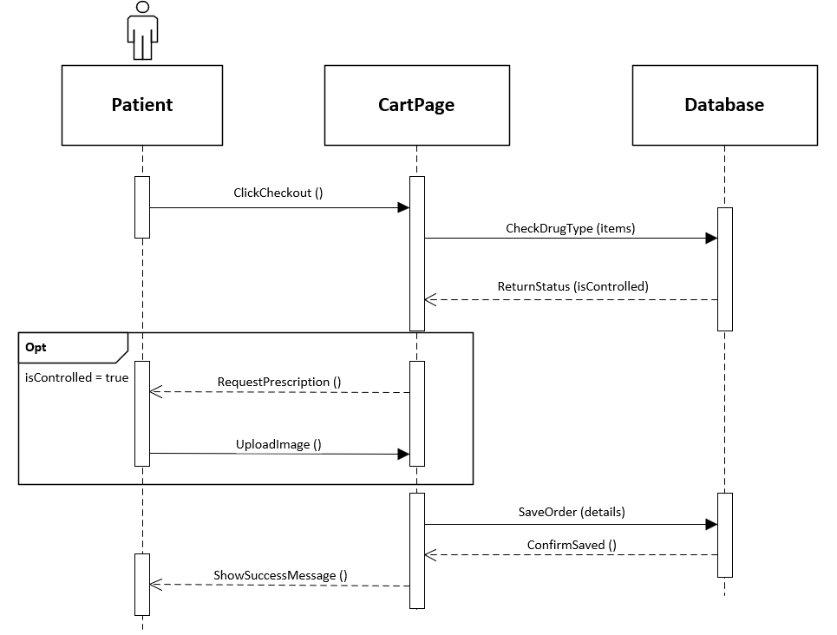
Figure ‎4.3.4 Sequence Diagram - Place Order

Manage Inventory
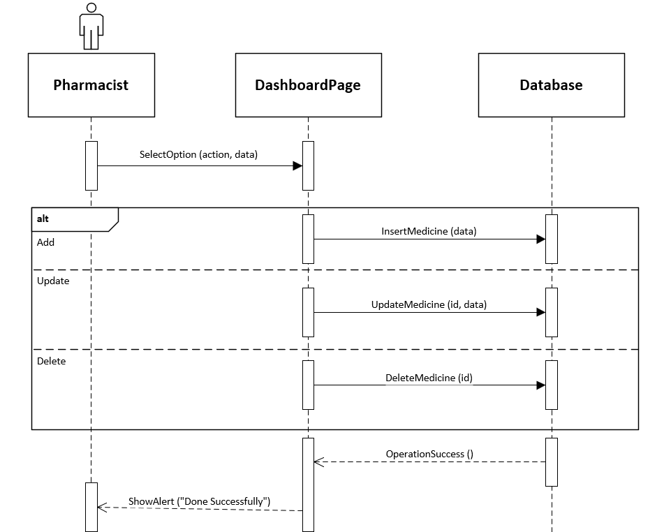
Figure ‎4.3.5 Sequence Diagram - Manage Inventory

Manage Orders
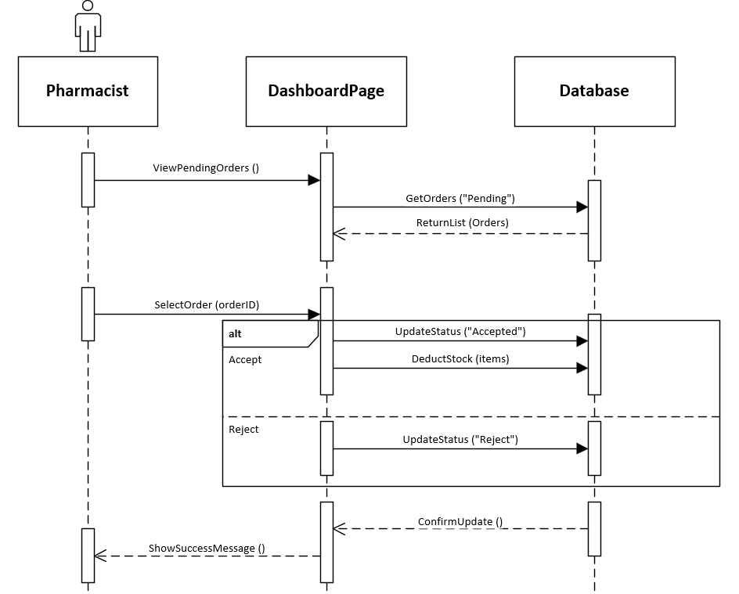
Figure ‎4.3.6 Sequence Diagram - Manage Orders

Entity Relationship Diagram (ER-model)
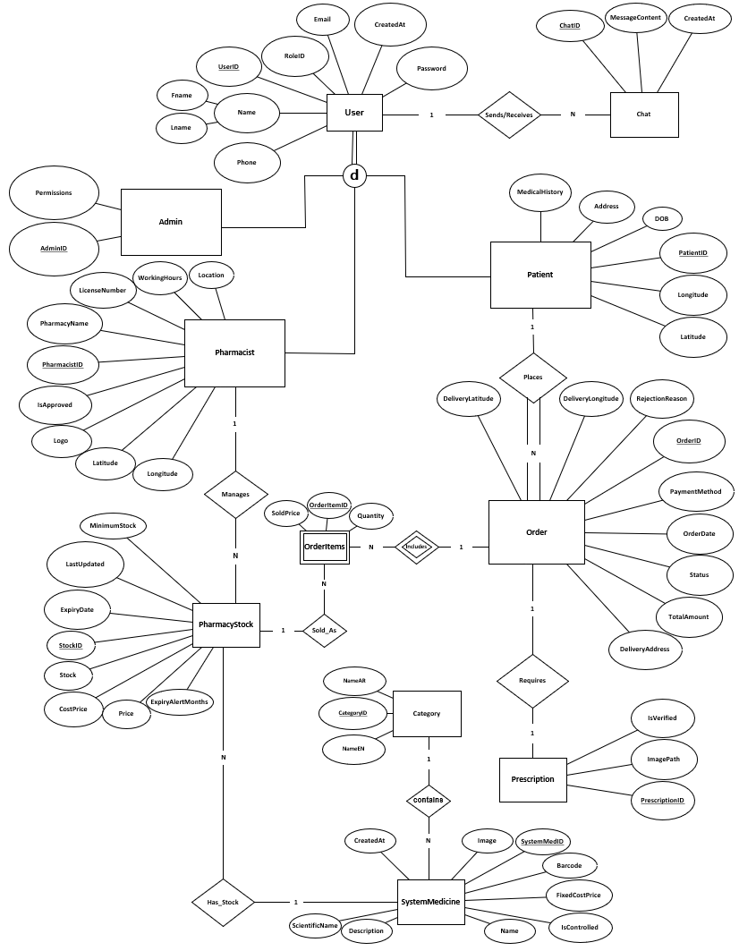
Figure ‎4.4.1 Entity Relationship Diagram

Activity Diagram

Patient Registration
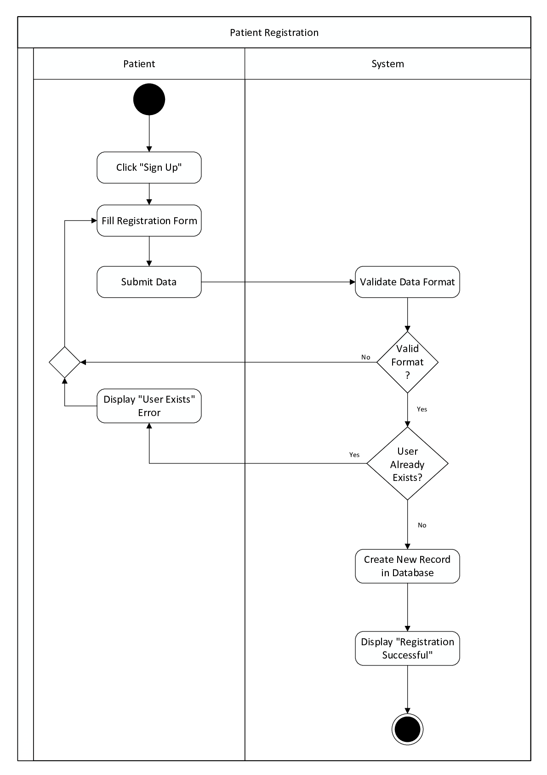
Figure ‎4.5.1 Activity Diagram - Patient Registration

Pharmacy Registration
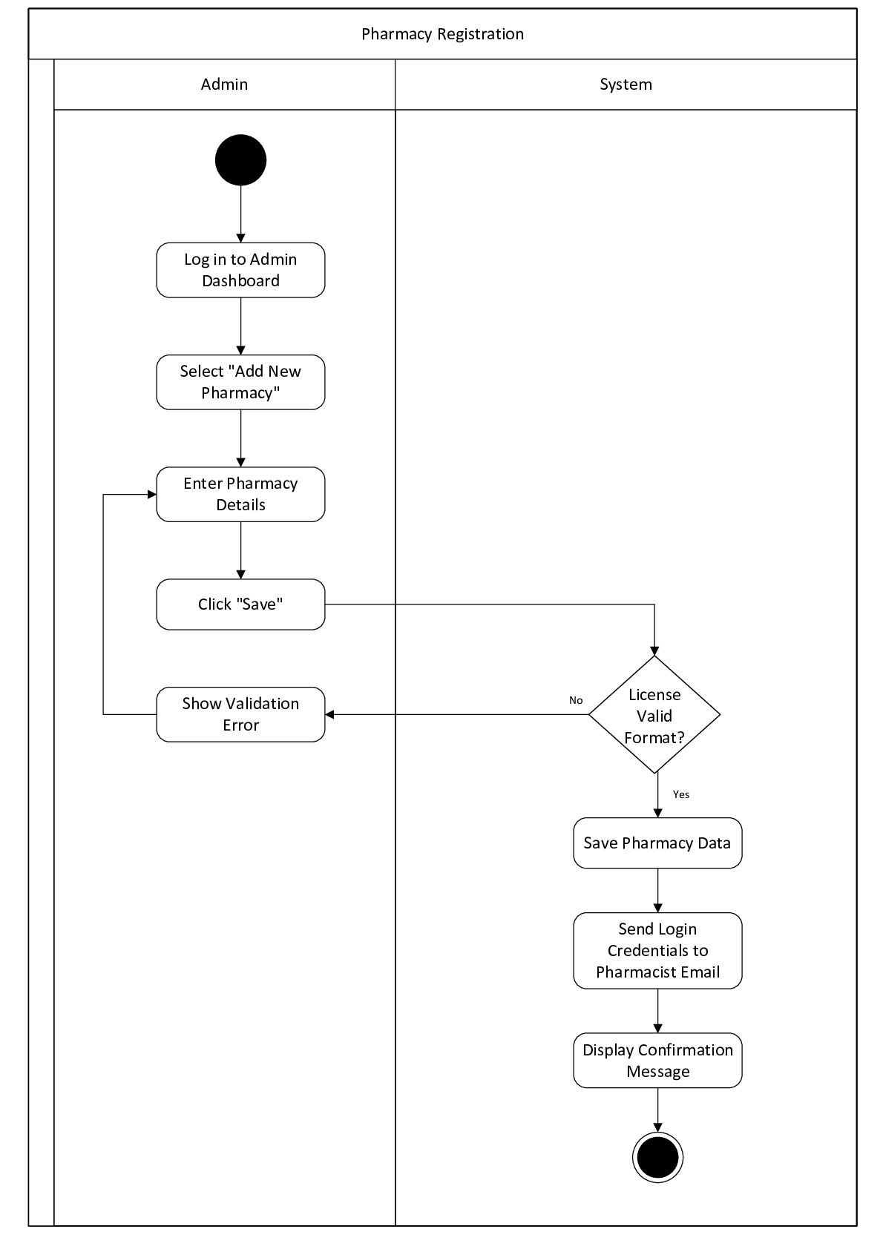
Figure ‎4.5.2 Activity Diagram - Pharmacy Registration

Login
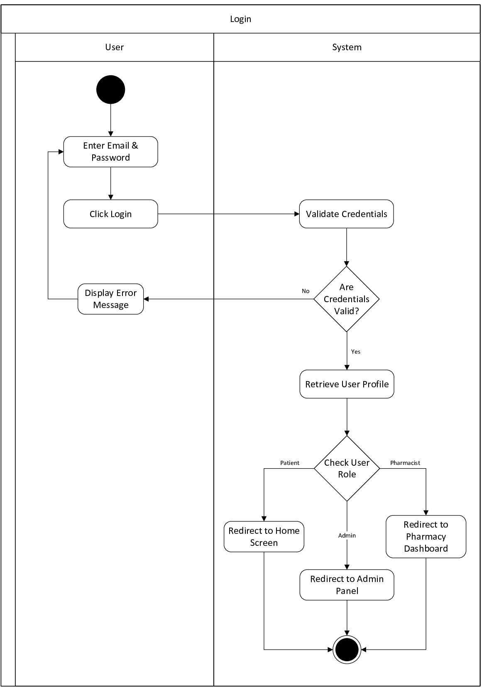
Figure ‎4.5.3 Activity Diagram - Login

Purchasing Process
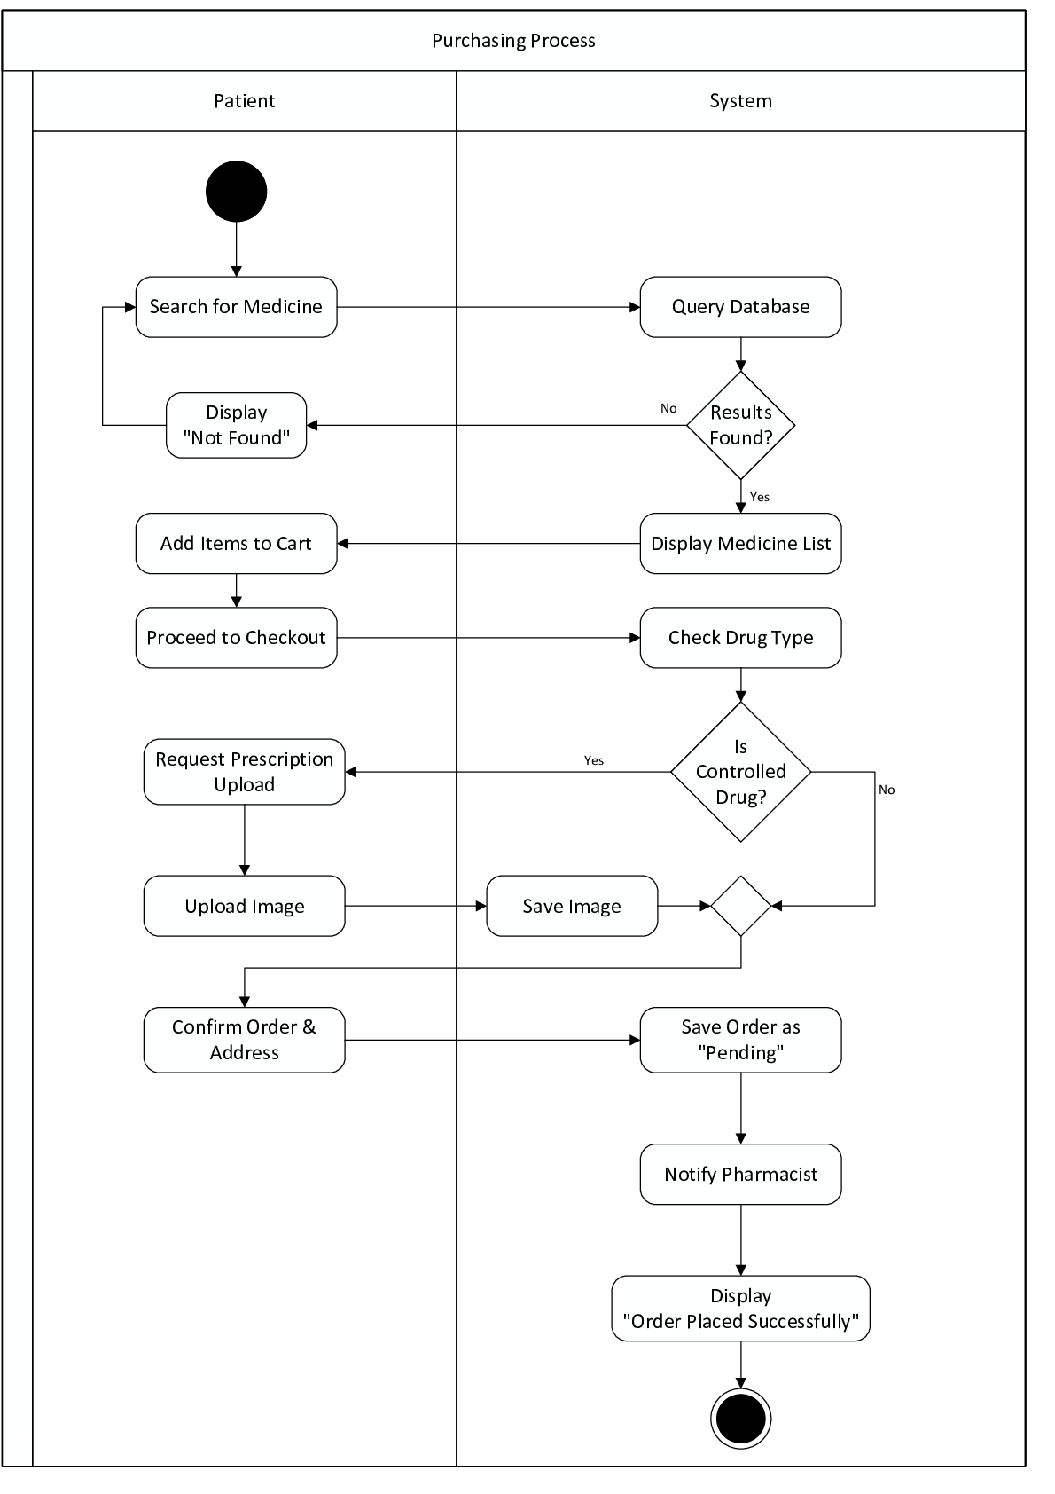
Figure ‎4.5.4 Activity Diagram - Purchasing Process

Pharmacist Order Handling
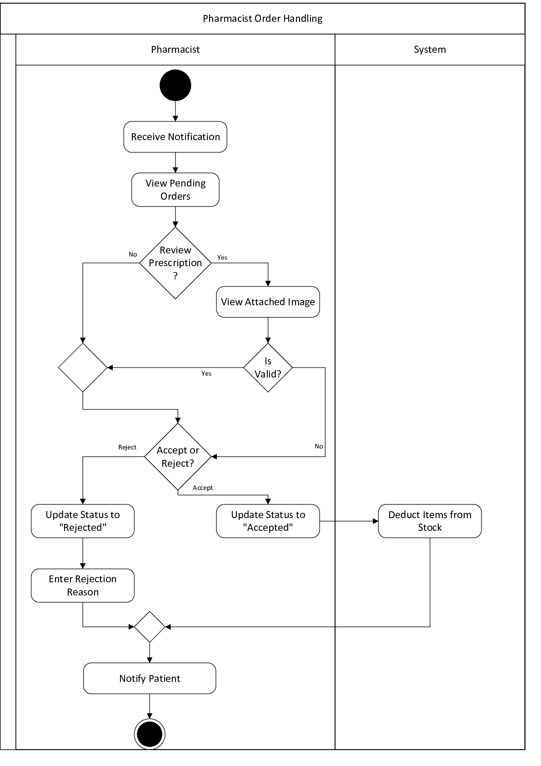
Figure ‎4.5.5 Activity Diagram - Pharmacist Order Handling

Inventory Management
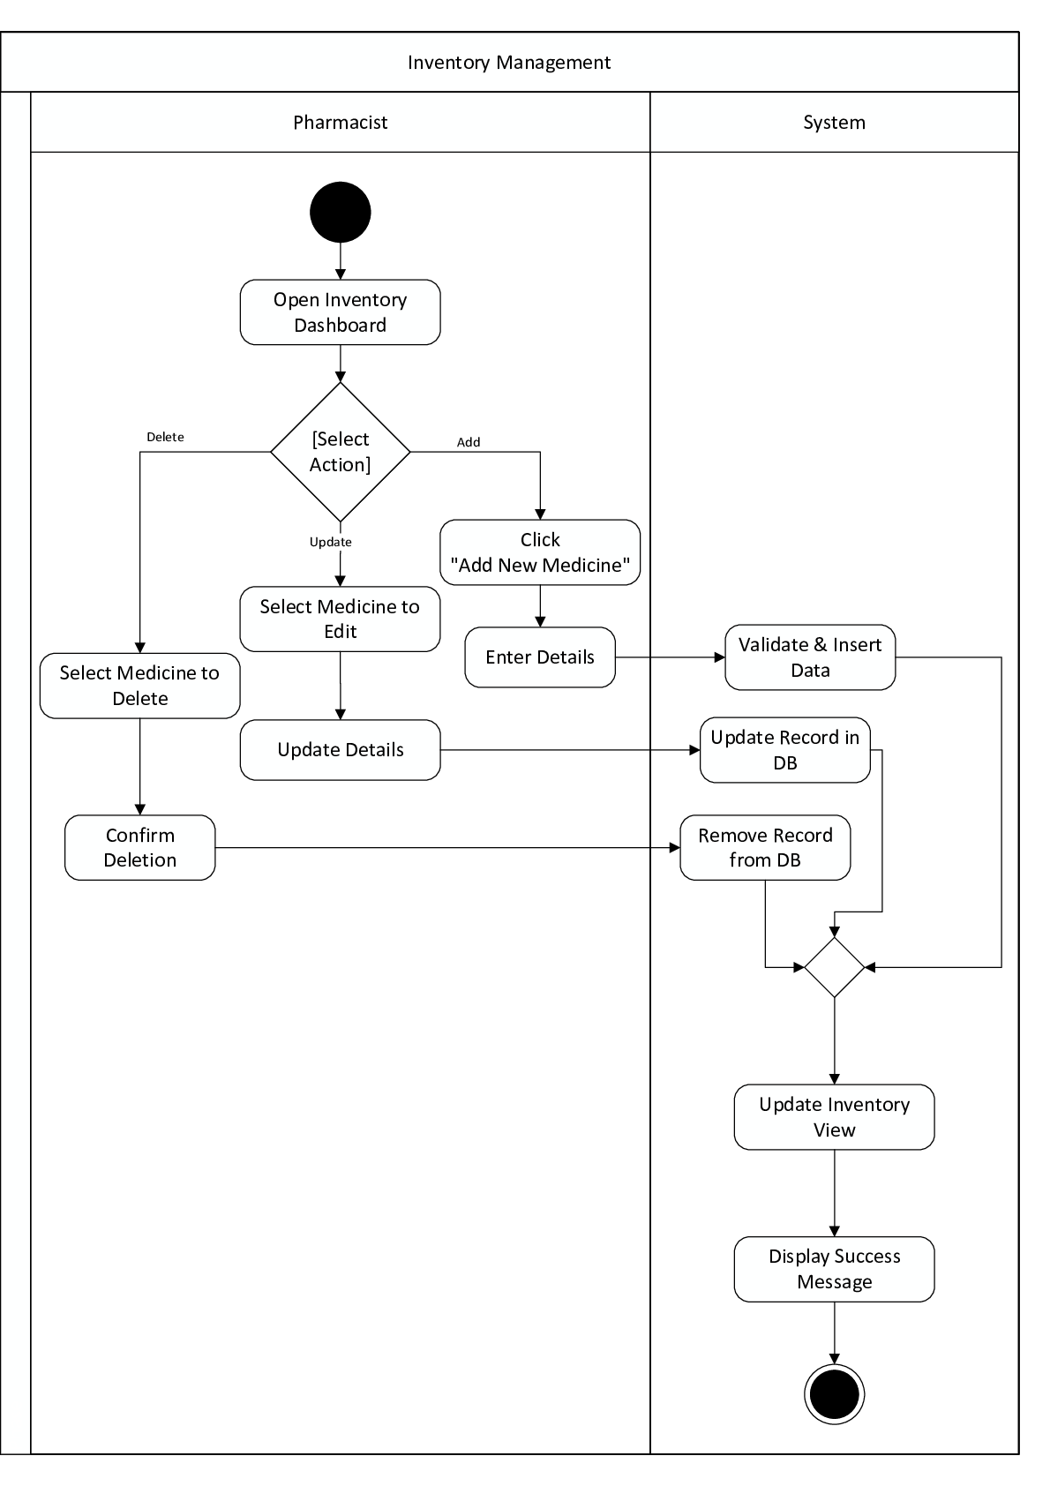
Figure ‎4.5.6 Activity Diagram - Inventory Management

System Interface

Patient Mobile Application (Flutter App)


Figure ‎4.6.1 Splash Screen

Figure ‎4.6.2 Onboarding Screen 1



Figure ‎4.6.3 Onboarding Screen 2


Figure ‎4.6.4 Onboarding Screen 3


Figure ‎4.6.5 Login Screen



Figure ‎4.6.6 Registration Screen 1

Figure ‎4.6.7 Registration Screen 2
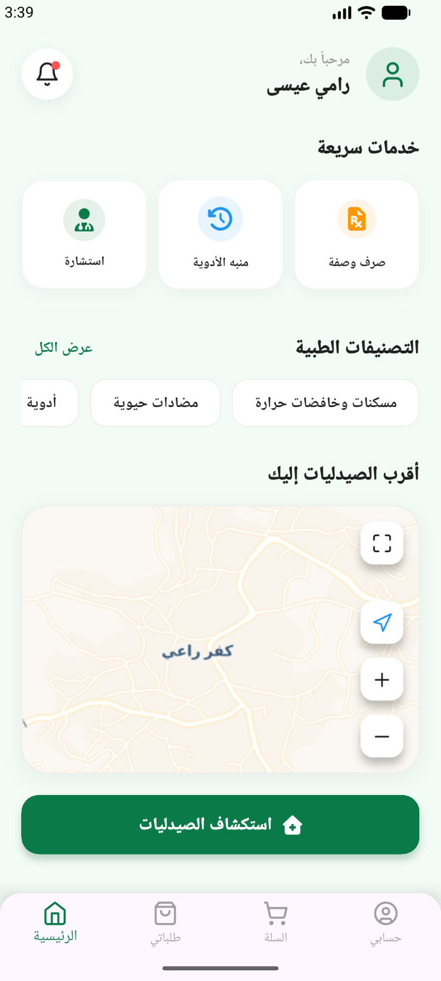
Figure ‎4.6.8 Main Screen
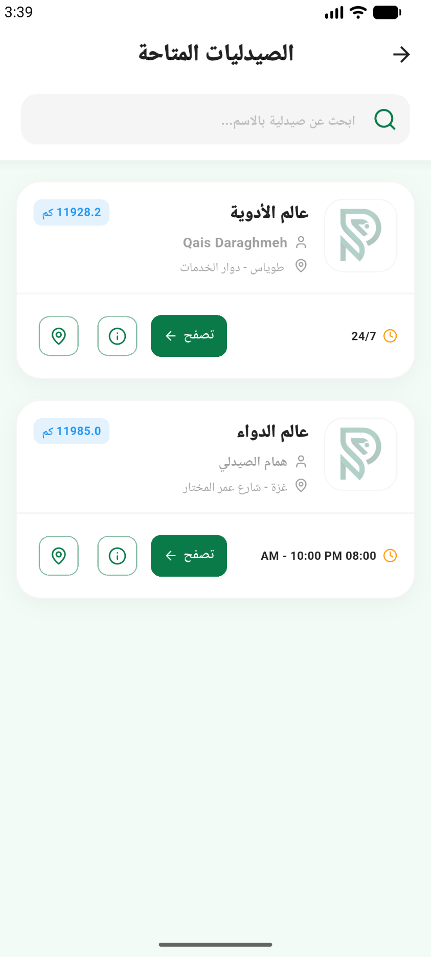
Figure ‎4.6.9 Pharmacies Screen

Figure ‎4.6.10 Pharmacy Details Screen
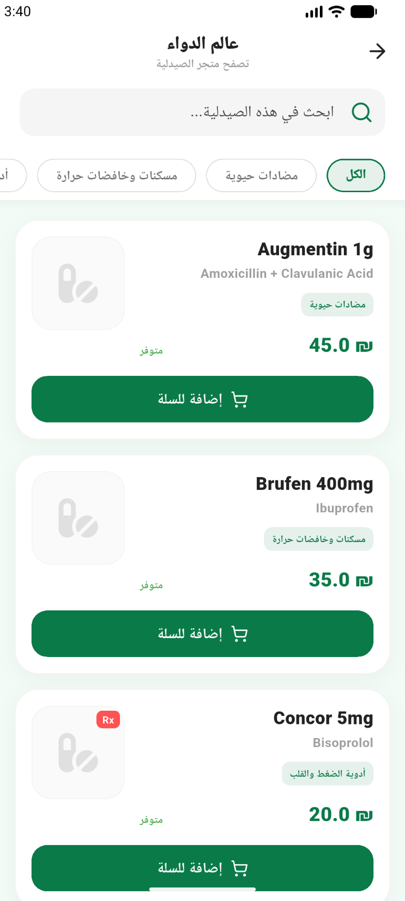
Figure ‎4.6.11 Pharmacy Store Screen

Figure ‎4.6.12 Notification Screen
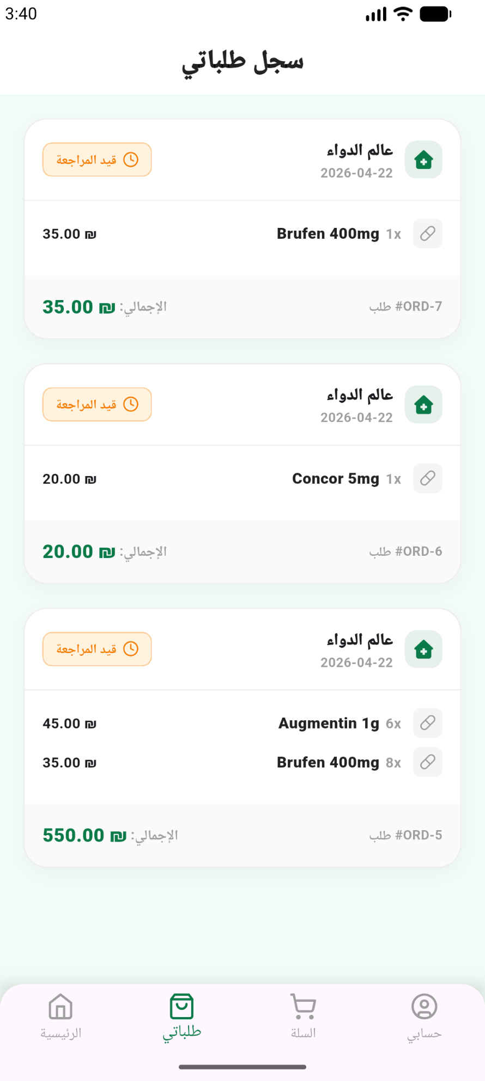
Figure ‎4.6.13 My Orders Screen
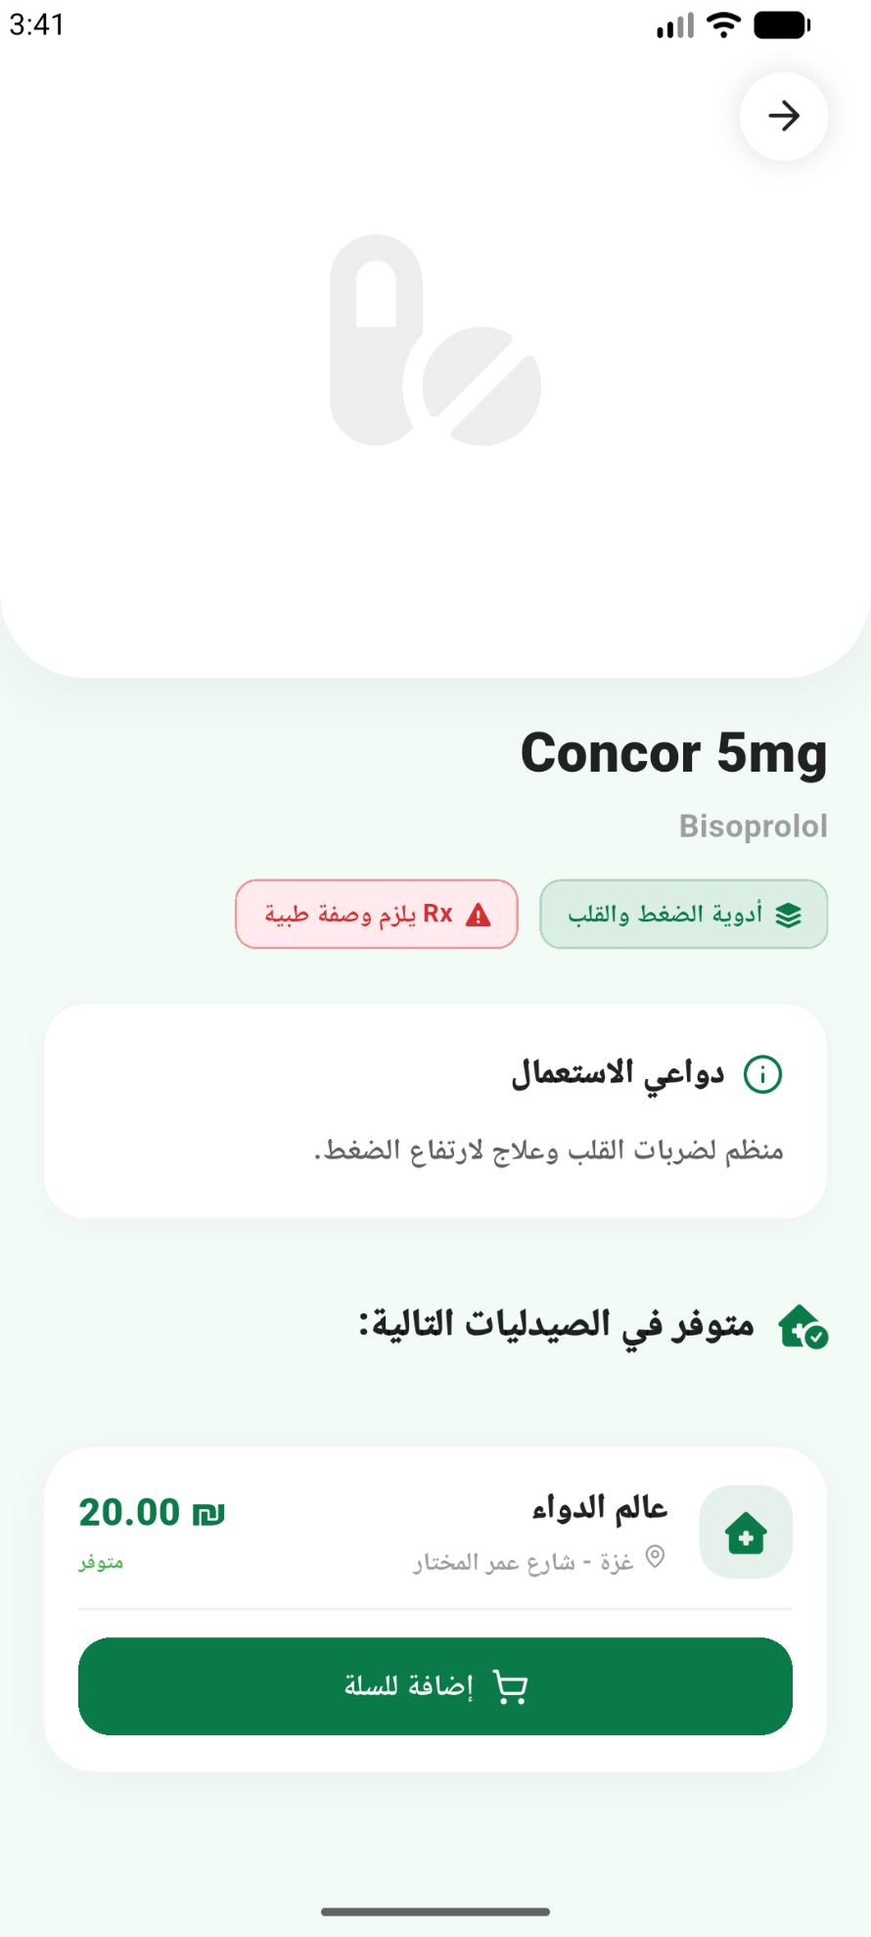
Figure ‎4.6.14 Medicine Details Screen
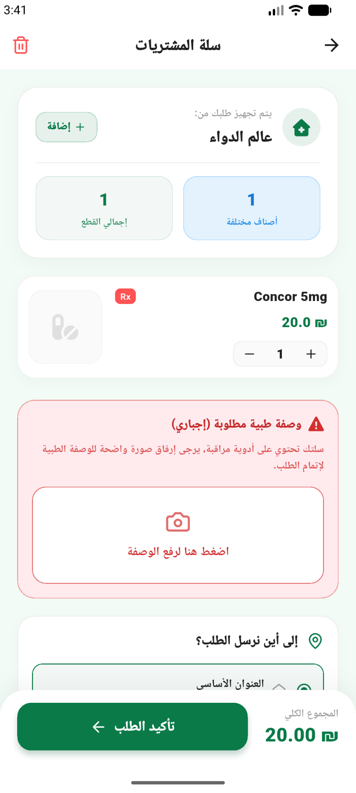
Figure ‎4.6.15 Cart Screen 1
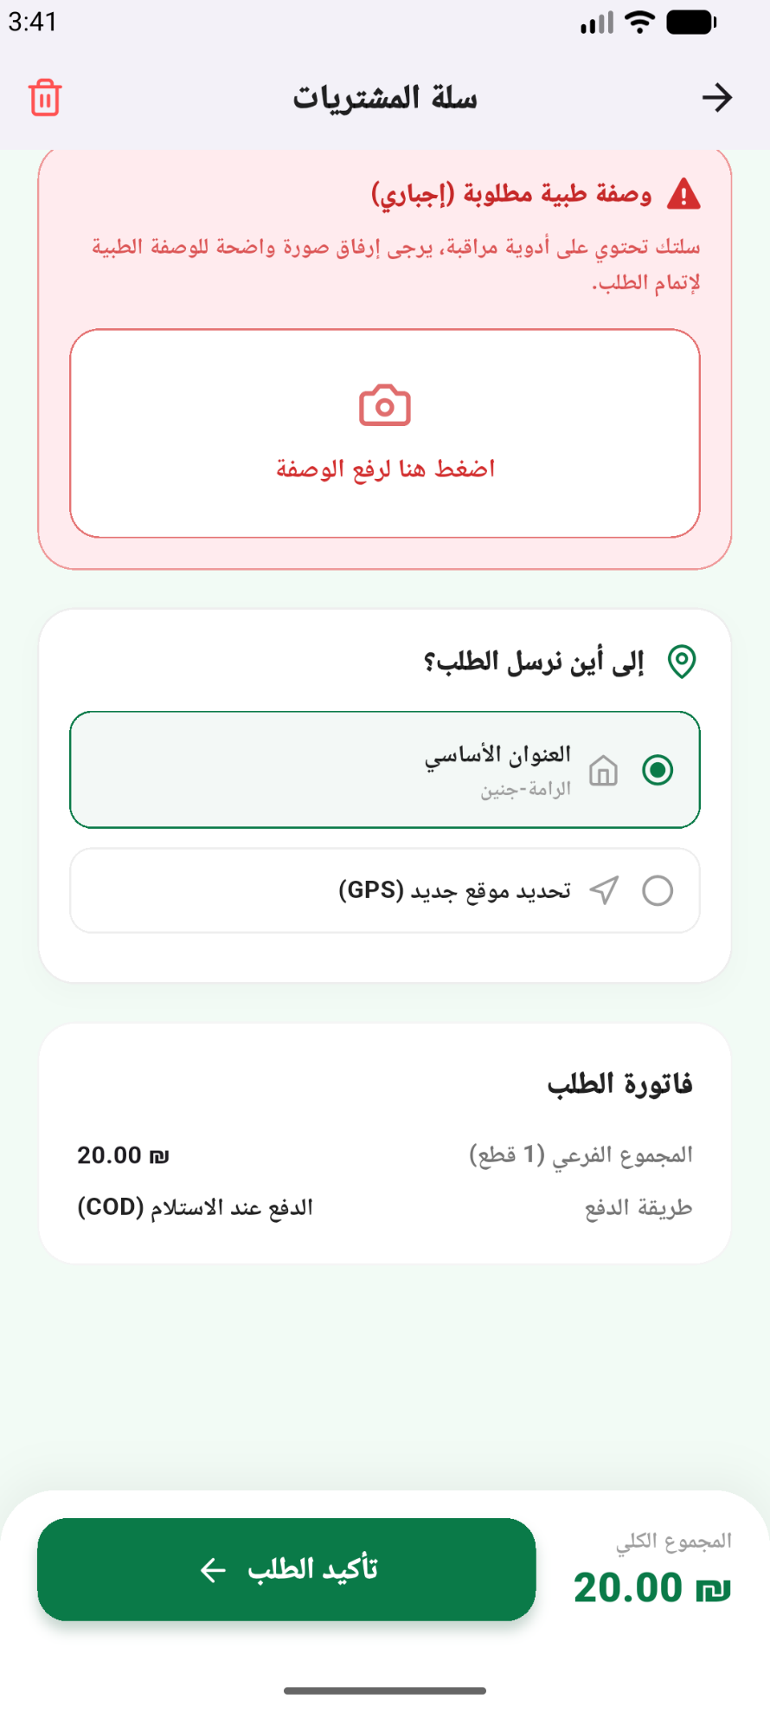
Figure ‎4.6.16 My Cart Screen 2

Figure ‎4.6.17 Profile Screen 1

Figure ‎4.6.18 Profile Screen 2

PharmaSmart Webpage

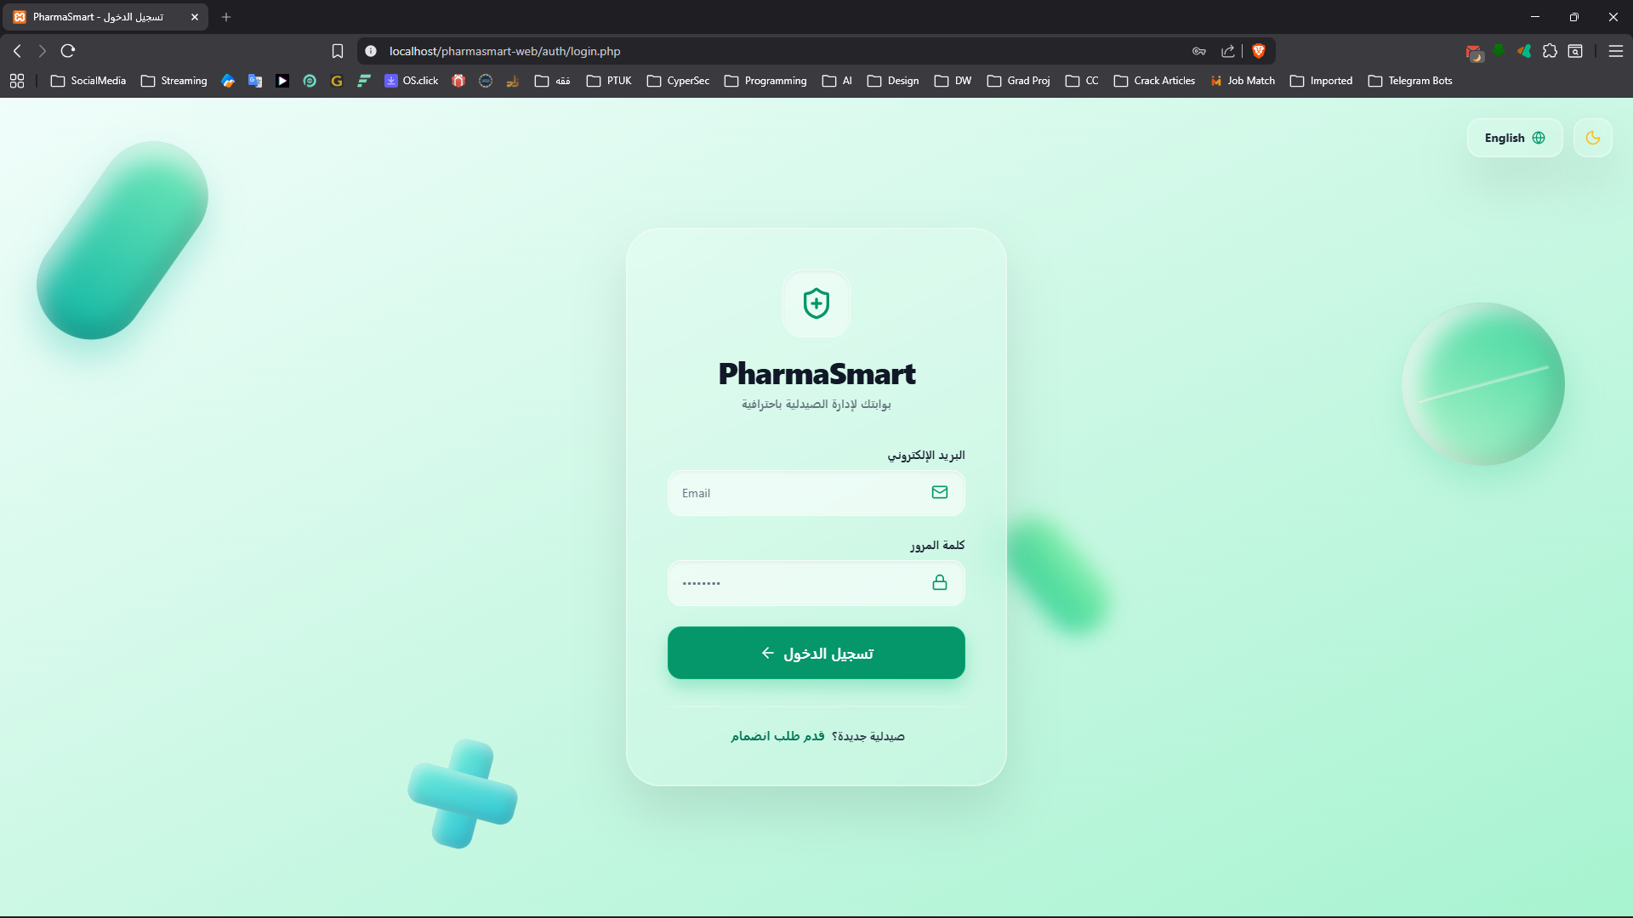
Figure ‎4.6.19 Webpage Login Screen
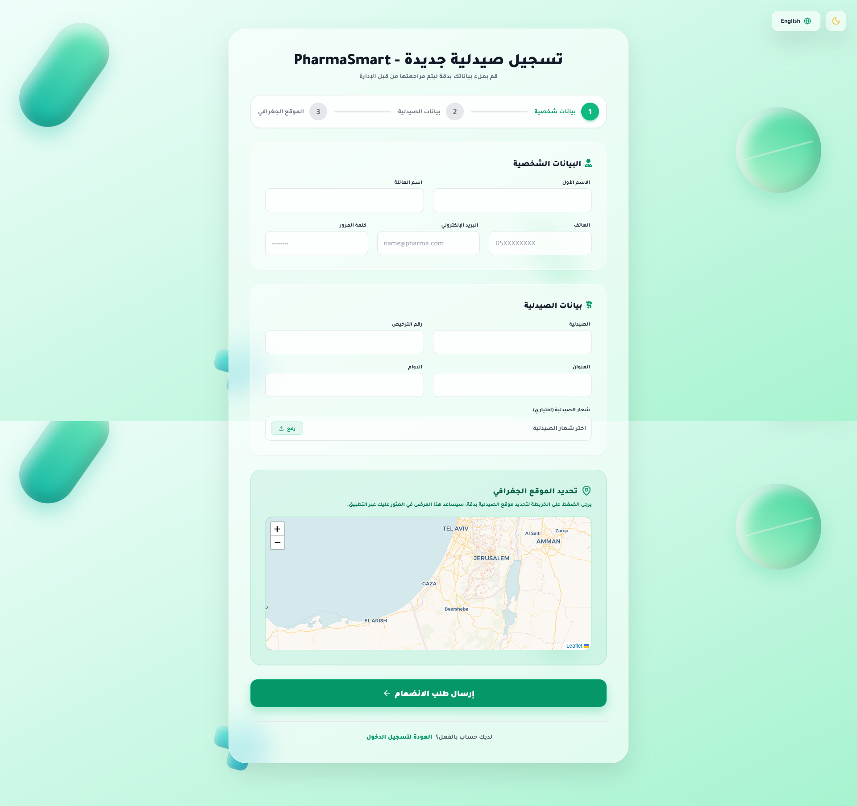

4.6.2.1 Admin Dashboard
Figure ‎4.6.20 Webpage Registration Screen
Figure ‎4.6.21 Admin Dashboard Screen
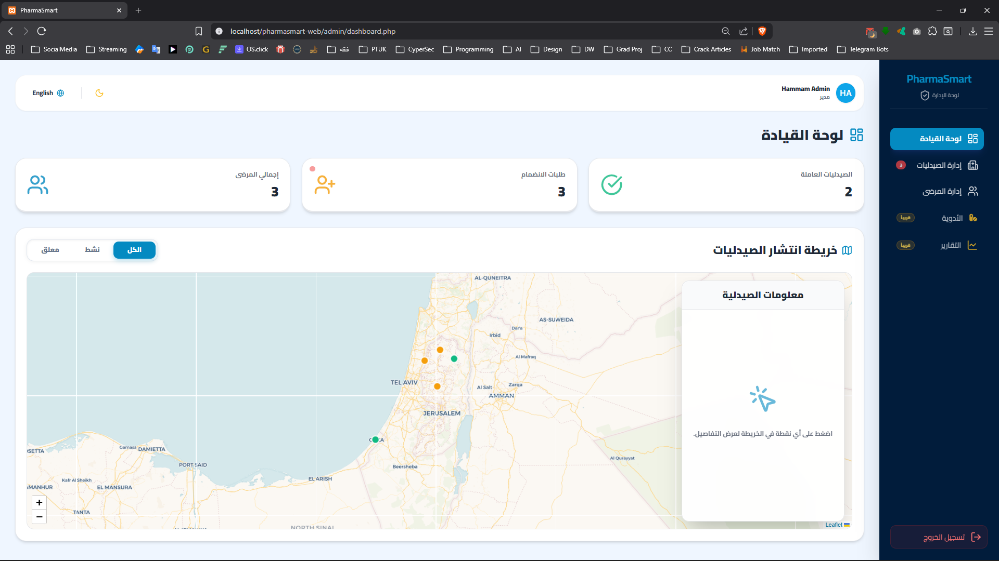
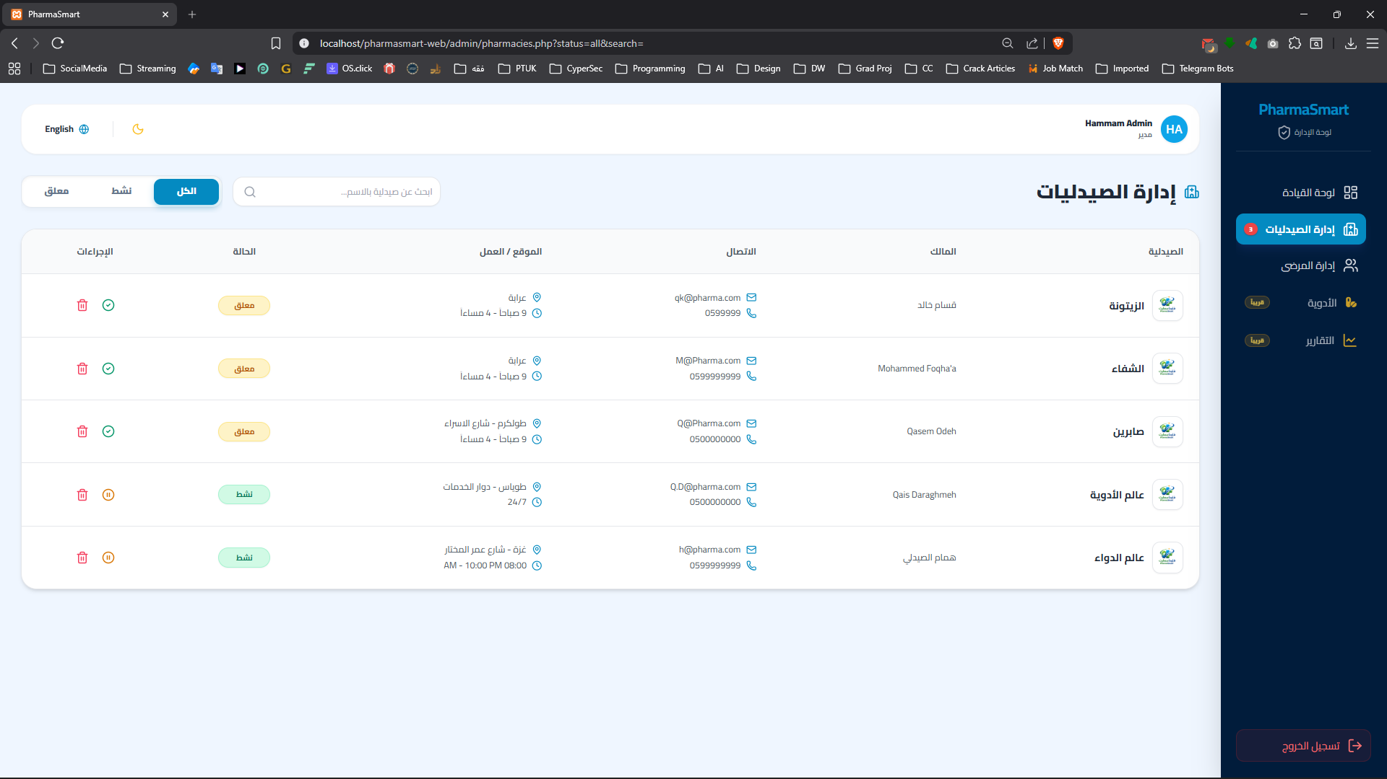
Figure ‎4.6.22 Admin Pharmacies Management Screen
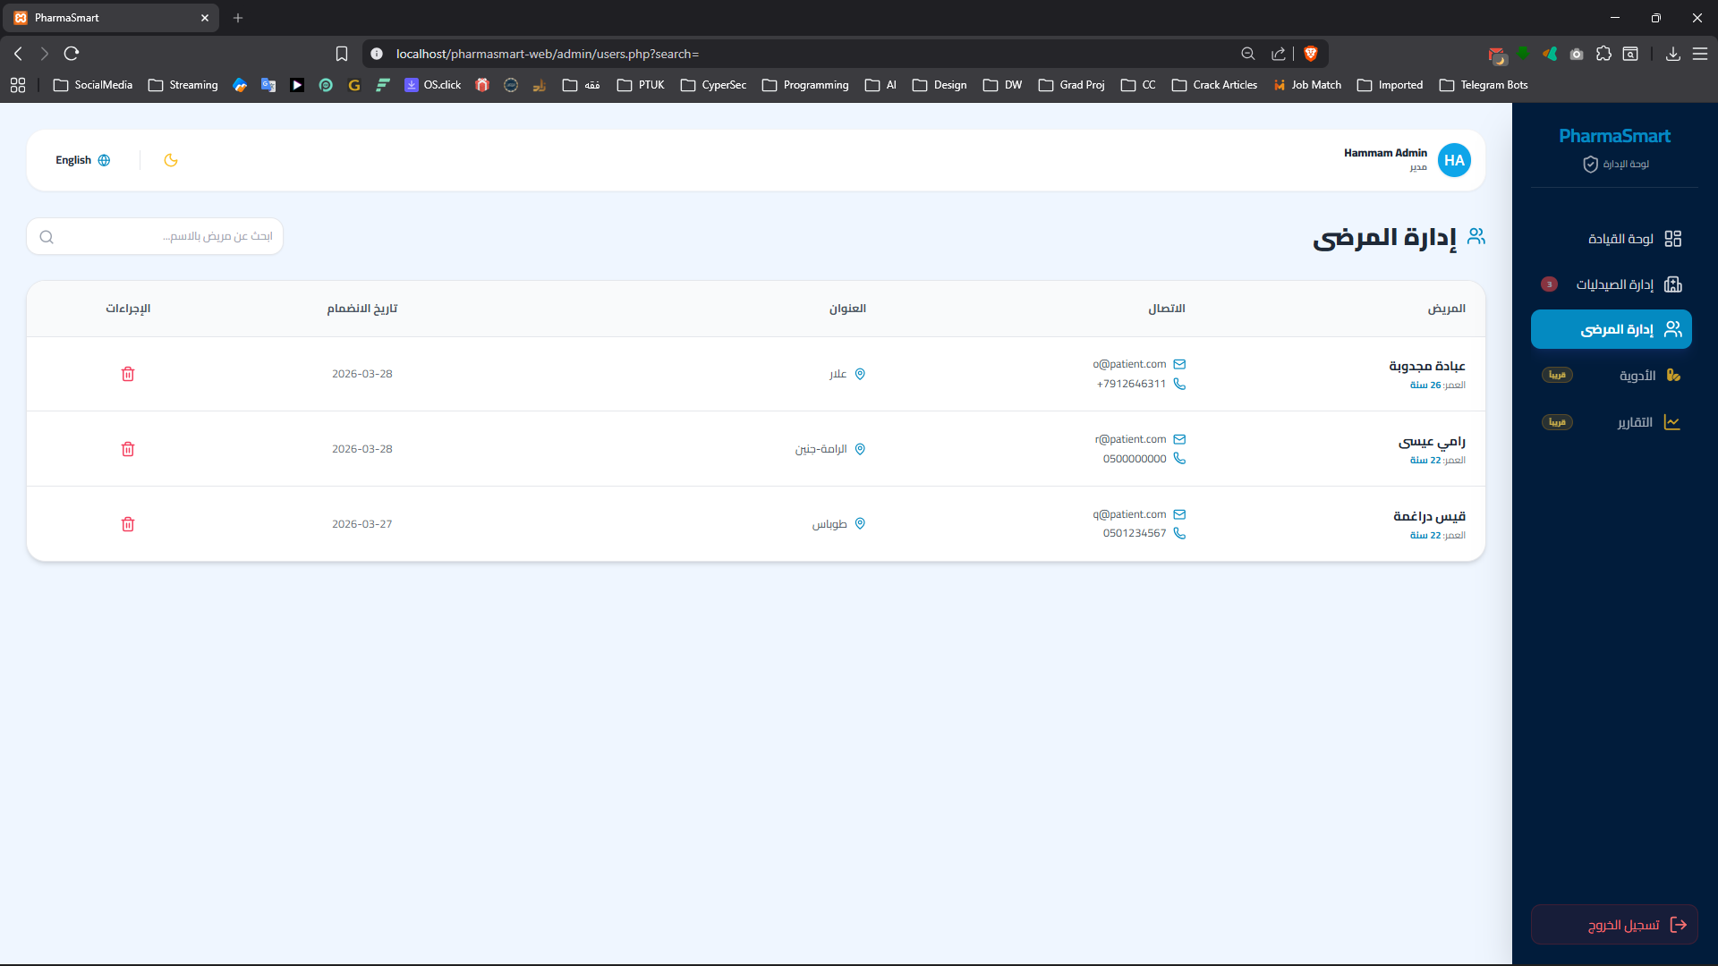
Figure ‎4.6.23 Admin Patients Management Screen

Pharmacist Dashboard
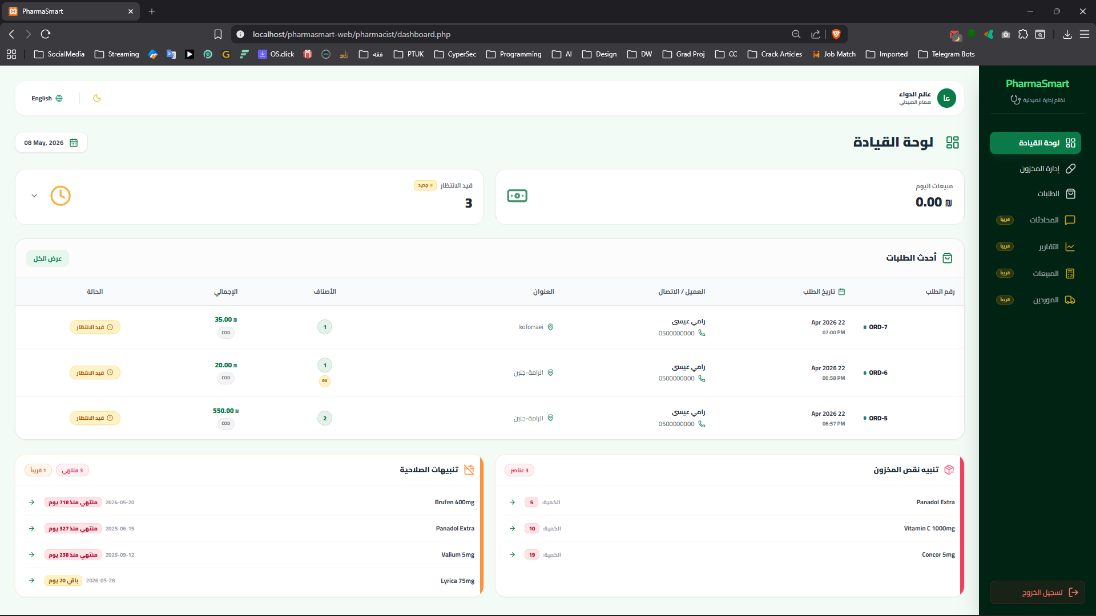
Figure ‎4.6.24 Pharmacist Dashboard Screen
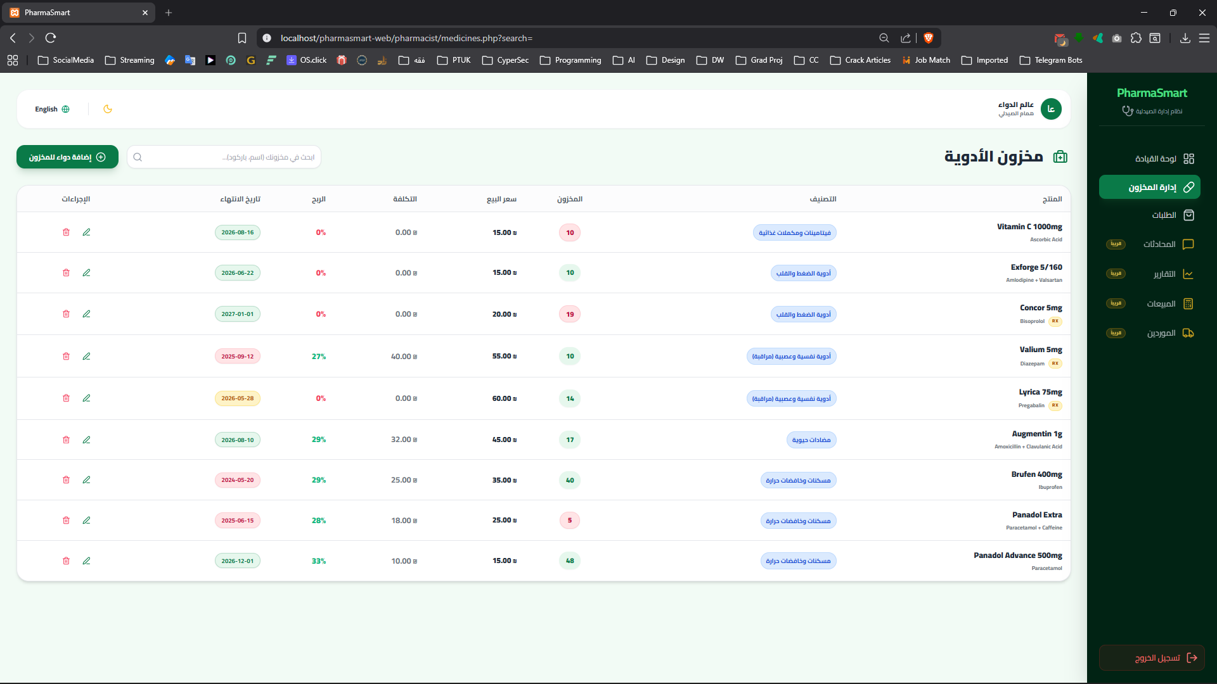
Figure ‎4.6.25 2 Pharmacist Medicine Screen
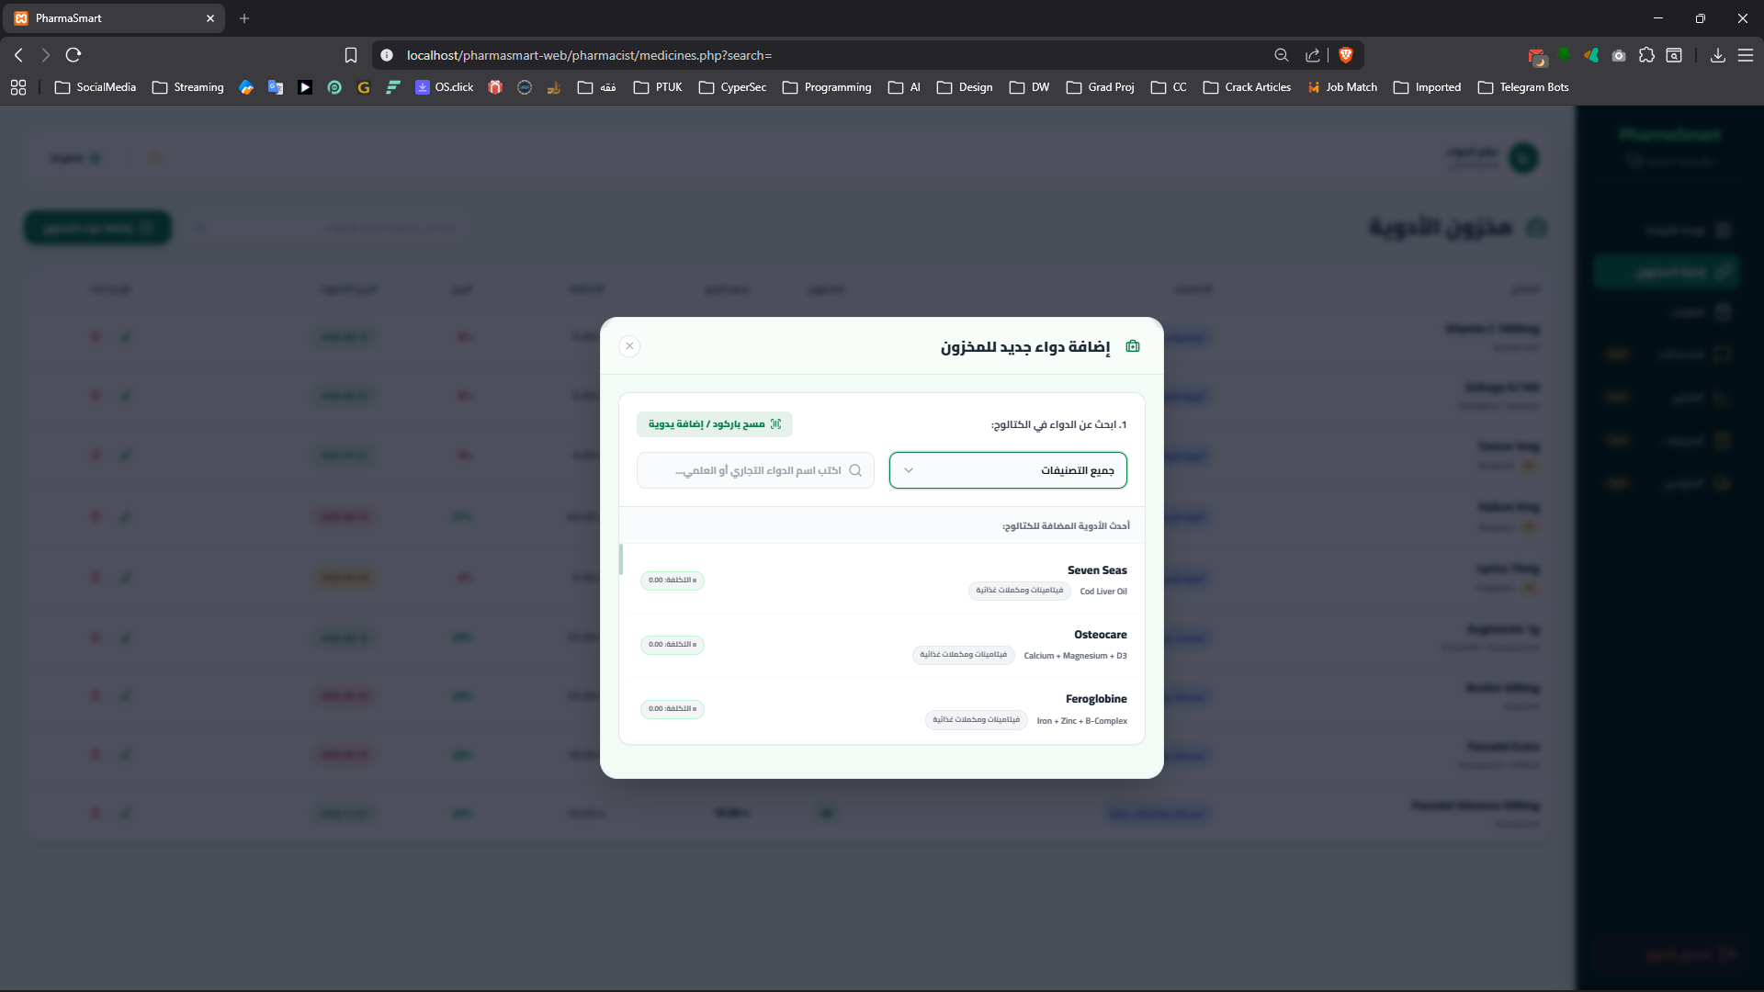
Figure ‎4.6.26 Add Medicine Screen
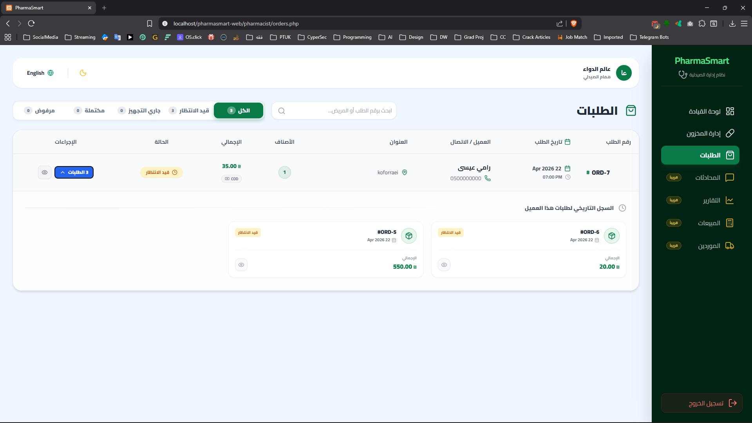
Figure ‎4.6.27 Order Screen
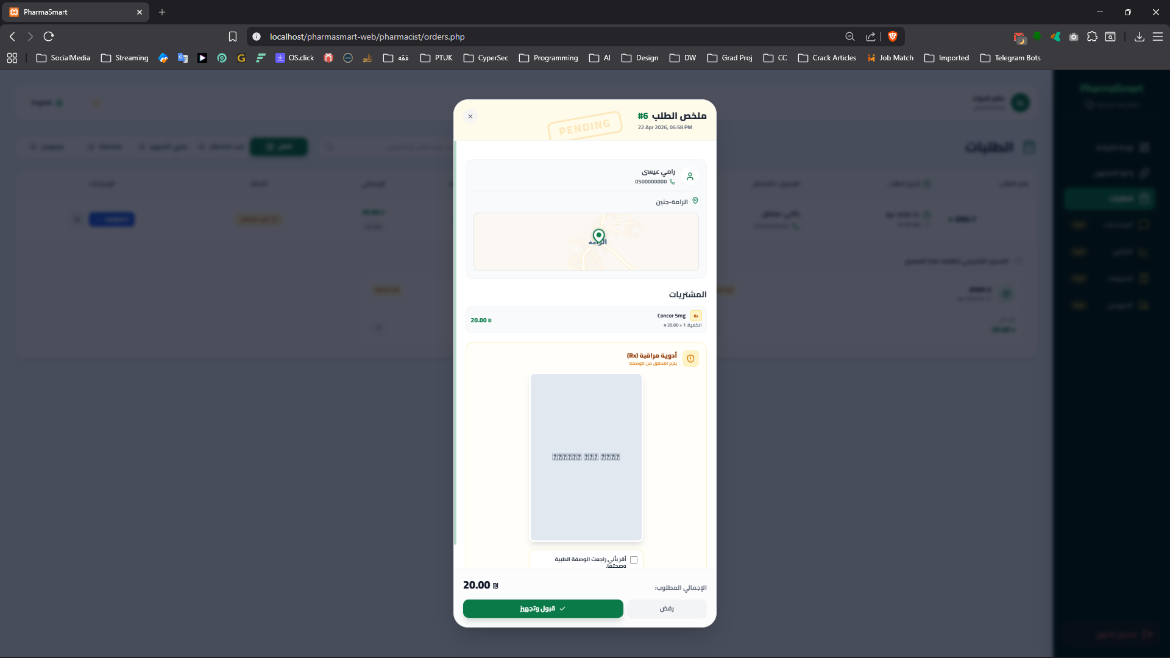
Figure ‎4.6.28 Order Details Screen

Summary
In this chapter, the system design was detailed through various UML diagrams to provide a comprehensive view of the PharmaSmart architecture. The Class Diagram was presented to define the static structure of the system, followed by Sequence Diagrams to illustrate the dynamic interactions between actors and system objects.
Furthermore, the database structure was defined using the Entity Relationship Diagram (ERD) to ensure data integrity. Finally, Activity Diagrams were designed to visualize the workflow of key processes such as registration, ordering, and inventory management. These design models serve as the blueprint for the next phase: System Implementation.

Chapter 5

Coding and Implementation

Introduction
The coding and implementation phase is where theoretical designs and defined requirements are translated into a fully functional software system. This chapter outlines the practical realization of the PharmaSmart platform. It details the selected technology stack, database configuration, development environment setup, and the execution of complex transactional logic. The successful completion of this phase ensures a seamless and secure integration between the patient-facing mobile application and the administrative web dashboards.

Coding Programming Languages
To ensure high performance, cross-platform compatibility, and a responsive user experience, a carefully selected stack of modern programming languages and frameworks was utilized:
- Dart & Flutter:
The client-side mobile application was entirely developed using the Flutter framework and Dart language. This approach allowed for the rapid deployment of a natively compiled application for mobile devices from a single codebase, utilizing efficient state management techniques to handle user interactions and cart logic.
- PHP:
Native PHP was employed to develop the server-side logic and RESTful APIs. It handles data processing, user authentication (utilizing secure password hash algorithms), and secure data transmission between the mobile application and the database.
- SQL:
Utilized extensively for database creation, data manipulation, and executing complex spatial queries, such as calculating geographic distances between patients and pharmacies.
- HTML, CSS, and JavaScript:
Formed the core of the web-based dashboards, providing structure and interactive client-side validations.
- Tailwind CSS:
A utility-first CSS framework integrated to rapidly build custom, responsive user interfaces, seamlessly enabling dynamic Dark/Light mode features across the web panels.

Database System
The backend data storage architecture relies on a robust relational database management system to ensure data integrity, security, and fast retrieval.
- DBMS Choice:
MySQL was selected for its reliability, speed, and seamless integration with the PHP backend environment.
- Database Connection & Localization:
The connection was established using the mysqli extension.
A critical implementation detail was defining the character encoding as utf8mb4 (mysqli_set_charset ($conn, "utf8mb4")) to guarantee complete and error-free support for the Arabic language across all platforms.
- Structural Implementation:
The database (pharmasmart_db) was implemented with strict relational constraints including Foreign Keys with ON DELETE CASCADE rules. A notable architectural achievement is the absolute separation between the SystemMedicine table (a globally managed catalog by the admin) and the PharmacyStock table (individual pharmacy inventories). This design prevents data redundancy and ensures standardized medication information system-wide.

Establishment of Development Environment
Setting up a cohesive and standardized development environment was crucial for testing the real-time integration between the mobile application and the local server.
- Development Tools (IDEs):
Visual Studio Code (VS Code) was utilized as the primary environment for both Flutter and PHP development, alongside Android Studio for mobile emulation and hardware debugging.
- Local Server & Routing:
XAMPP was configured as the local hosting server. To allow the Flutter application to communicate with the local PHP APIs.
- Flutter Dependencies:
Key external libraries were integrated via pubspec.yaml to enhance system functionality, notably:
  - http: For executing asynchronous REST API calls.
  - shared_preferences: For local session storage and managing user/guest states.
  - flutter_map & latlong2: For rendering interactive OpenStreetMap tiles and handling geographic coordinates.
  - geolocator: To fetch real-time and accurate user locations.
  - image_picker: To access the device camera and gallery for uploading Medical Prescriptions (Rx).
  - awesome_dialog & lucide_icons: To provide modern UI/UX elements and interactive user alerts.

Stored Procedures and Transactional Logic
To maintain backend flexibility and reduce database bottlenecks, procedural logic and strict database transactions were heavily implemented inside the PHP API layer. This approach ensures the ACID properties (Atomicity, Consistency, Isolation, Durability) of the system.
- Transactional Order Processing: In the order placement API (create_order.php), creating a patient order involves inserting data into multiple related tables sequentially (Order, OrderItems, and Prescription).
This logic is wrapped inside a mysqli_begin_transaction (). If any step fails—such as a failure in saving the Base64 prescription image—a mysqli_rollback () is triggered to discard incomplete data, ensuring absolute database consistency.
- Complex Spatial Queries:
Instead of calculating distances on the client-side, a procedural SQL query was constructed utilizing trigonometric functions (acos, cos, sin, radians) to execute the Haversine formula directly within the database. This drastically reduces the mobile app's processing load and sorts pharmacies by proximity with high accuracy.
- Inventory Deduction Logic: During the order processing phase, accepting an order triggers an automated query that updates the PharmacyStock. This ensures real-time stock management and prevents negative inventory anomalies by mathematically constraining stock levels.

Summary and Recommendations
This chapter comprehensively detailed the coding and implementation phase of the PharmaSmart project. The system was successfully materialized using a modern, scalable technology stack: Flutter for the cross-platform mobile client, Native PHP and MySQL for the robust backend architecture, and Tailwind CSS alongside JavaScript for the responsive administrative web dashboards.
By establishing a well-configured development environment and adhering to strict software engineering practices—such as implementing ACID-compliant database transactions and server-side procedural logic—the development phase yielded a highly functional, stable, and integrated platform. The current implementation successfully fulfills all the functional and non-functional requirements defined in the earlier stages of this research.

Chapter 6

System Testing

Introduction
System Testing is a critical phase in the Software Development Life Cycle (SDLC), designed to evaluate the complete and integrated system to ensure strict compliance with its specified requirements. In the PharmaSmart project, this phase involved rigorous testing of the complex interactions between the Flutter mobile application, the PHP RESTful APIs, the MySQL database, and the web-based administrative dashboards. The primary objective of this chapter is to outline the testing methodologies applied to identify software defects, validate system security, ensure data integrity, and guarantee a seamless User Experience (UX) across all platforms prior to final deployment.

Specification Testing
Specification testing was conducted to verify that the developed system directly aligns with the Functional Requirements (FR) and Non-Functional Requirements (NFR) outlined in Chapter 3.
- Functional Specification Validation:
Key business rules were meticulously tested. For instance, the "Single Pharmacy Constraint" was verified to ensure that a patient cannot add medications from two different pharmacies to the same shopping cart. Additionally, the Prescription Verification Protocol (Rx) was successfully validated; the system correctly blocks the checkout process if an item flagged with IsControlled = 1 is in the cart without a properly uploaded prescription image.
- Non-Functional Specification Validation:
The system’s responsiveness, usability, and adaptability were tested. The Web Dashboard was evaluated across various screen dimensions (utilizing Tailwind CSS breakpoints) and verified to toggle seamlessly between Dark and Light modes. Furthermore, localization matrices (lang.php) were tested to ensure the interface switches flawlessly between Arabic (RTL) and English (LTR) layouts without breaking the UI components

Black Box Testing
Black box testing was conducted to evaluate the functionality of the PharmaSmart system without looking at the internal code structure. The testing was carried out using standard Test Cases to cover valid and invalid inputs across the mobile application and web dashboards.

Test Case ID | Scenario Description | Input Data | Expected Output | Actual Output | Status
TC-LOG-01 | Valid Patient Login | Valid Email +  Valid Password | Redirect to Mobile Home Screen | Redirected successfully | Pass
TC-LOG-02 | Invalid Password | Valid Email + Wrong Password | Show "Incorrect Password" error alert | Showed error alert | Pass
TC-LOG-03 | Pharmacist Pending Approval | Valid Email + Valid Password (IsApproved = 0) | Block access, show "Pending Admin Approval" alert | Blocked and showed alert | Pass
TC-LOG-04 | Role-Based Access Control (RBAC) | Patient credentials entered in Web Dashboard | Block access, show "Web is for Pharmacists/Admin only" | Blocked and showed alert | Pass
Table ‎6.3.1 User Authentication (Login) Test Cases

Test Case ID | Scenario Description | Input Data | Expected Output | Actual Output | Status
TC-REG-01 | Valid Registration | All fields filled + GPS coordinates picked | Account created, redirect to Login screen | Account created | Pass
TC-REG-02 | Missing GPS Location | All fields filled + No map location selected | Prevent submission, show "Location is required" warning | Showed warning | Pass
TC-REG-03 | Duplicate Email | Already registered Email + Valid Password | Prevent submission, show "Email already exists" error | Showed error | Pass
Table ‎6.3.2 Patient Registration (Sign-up) Test Cases

Test Case ID | Scenario Description | Input Data | Expected Output | Actual Output | Status
TC-CRT-01 | Single Pharmacy Constraint | Add Med from Pharmacy (A), then Med from Pharmacy (B) | Show "Pharmacy Conflict" alert asking to clear cart | Showed conflict alert | Pass
TC-CTR-02 | Controlled Medicine (Rx) Checkout | Cart has (IsControlled=1) item + No Prescription Image | Prevent checkout, show "Prescription Required" alert | Prevented checkout | Pass
TC-CTR-03 | Valid Checkout | Valid Cart + Delivery Address + Prescription (if Rx) | Generate Order ID, clear cart, navigate to Success screen | Order generated | Pass
Table ‎6.3.3 Shopping Cart & Checkout Test Cases

White Box Testing
White box testing was performed to verify the internal mechanisms, database transactions, and procedural logic of the PHP RESTful APIs. Database Transactions Logic:
Test Case ID | Scenario Description | Input Data | Expected Output | Actual Output | Status
TC-WB-01 | Order Rejection Constraint | Pharmacist clicks "Reject" but leaves the reason field empty | API validation blocks execution, UI shows "Reason Required" | Execution blocked | Pass
TC-WB-02 | Inventory Deduction Logic | Pharmacist clicks "Accept" order | Backend deducts item quantities from PharmacyStock | Stock successfully updated | Pass
TC-WB-03 | Rollback on Failure | Simulate server failure midway during create_order.php execution | mysqli_rollback () triggers, preventing partial data insertion | No orphaned records saved | Pass
TC-WB-04 | Spatial Search Logic | Mobile sends GPS coordinates to search_medicines.php | Haversine formula executes in SQL, returning nearest pharmacies | Results sorted correctly by distance | Pass
Table ‎6.4.1 Database Transactions and Order Processing

Regression Testing
Regression testing was performed continuously during the Agile development sprints to ensure that newly added features did not inadvertently break existing, stable functionalities.
- Database Schema Updates:
When the system transitioned from local isolated pharmacy inventories to a centralized SystemMedicine catalog, regression tests were run on the search engine and the mobile state management (CartService). The tests ensured the system still accurately fetched prices, scientific names, and pharmacist associations without relational errors.
- Package Integration:
After integrating complex Flutter packages, such as flutter_map and geolocator, the mobile application was thoroughly re-tested. This ensured that heavy map rendering processes did not cause memory leaks, UI freezing, or conflicts with the application's routing and navigation stack.

Unit Testing
Unit testing focused on isolating specific functions and methods within the codebase to ensure they return the exact expected outputs under various edge-case conditions.
- Flutter State Management (Dart):
The addItem method inside the CartService class was unit-tested. It was successfully verified that passing an identical stockId increments the quantity integer rather than duplicating the list item. Furthermore, testing confirmed that the method accurately returns a pharmacy_conflict string flag when a pharmacistId mismatch is detected.
- Backend Mathematical Logic (PHP):
The dynamic profit margin calculation logic (($price - $cost) / $price * 100) was tested to ensure it handles zero-division and negative scenarios gracefully. Additionally, the inventory deduction query was tested to ensure the use of the GREATEST (Stock - quantity, 0) SQL function effectively prevents stock levels from dropping into negative integers.

Summary and Recommendations
The extensive testing procedures detailed in this chapter ranging from Black Box UI evaluations to White Box database transaction validations demonstrate that the Pharma Smart platform is a highly stable, secure, and robust system. The integration between the Flutter mobile client and the PHP/MySQL backend functions seamlessly, effectively handling complex operational scenarios such as shopping cart conflicts, geographic location routing, and strict medical prescription verification protocols. The testing phase confirms that the system is reliable and fully meets the objectives outlined at the project's inception.
Chapter 7

Conclusions and Future Works

Conclusions
This project successfully delivered PharmaSmart an integrated digital healthcare marketplace designed to bridge the gap between patients and local pharmacies in Palestine. By leveraging a robust decoupled architecture combining a cross-platform mobile application (Flutter/Dart) with a secure, responsive administrative backend (Native PHP, MySQL, and Tailwind CSS) the platform provides a seamless e-commerce experience tailored to the pharmaceutical sector.
Throughout the SDLC, several core objectives were achieved:
- Geographic Integration: Successfully implemented OpenStreetMap (via Leaflet.js and flutter_map) to calculate accurate distances between patients and pharmacies using GPS coordinates.
- Inventory & Pricing Management: Developed a dynamic pharmacy dashboard that allows pharmacists to manage stock, calculate profit margins in real-time, and receive automated alerts for low stock and imminent expiry dates.
- Medical Compliance: Enforced a strict Prescription Verification Protocol (Rx), ensuring that controlled medications cannot be ordered without the submission and subsequent pharmacist validation of a medical prescription image.
Ultimately, the PharmaSmart project proves that digital transformation can significantly mitigate the traditional challenges of locating specific medications, thereby enhancing healthcare accessibility, saving time, and empowering local pharmacy businesses.

Future Works
Due to the defined timeframe of the graduation project, development was strictly focused on delivering a fully functional and highly stable Minimum Viable Product (MVP). During the implementation phase, several advanced features were architecturally planned, leaving UI placeholders tagged with "Coming Soon" across the mobile and web interfaces. The immediate roadmap for future development includes:
- Patient Experience Enhancements:
- Online Payment Gateway: Expanding the current "Cash on Delivery" (COD) model to integrate secure electronic payment APIs for Credit/Debit cards (Visa/MasterCard).
- Smart Medication Reminder: Activating the planned push-notification system to remind patients of their scheduled medication doses.
- Mobile Personalization: Activating the "Dark Mode" toggle and "Language Switcher (AR/EN)" within the mobile app's profile screen to match the web dashboard's capabilities.
- Password Recovery System: Integrating an SMTP server to execute the planned "Forgot Password" functionality via email verification.
- Pharmacist and Administrative Features:
- Live Consultation System (Chat): Activating the real-time messaging module to allow patients to consult directly with pharmacists regarding prescriptions.
- Advanced Analytics & Sales Dashboard: Completing the graphical interfaces for the "Reports" and "Sales" sections, enabling pharmacists to view interactive charts regarding their daily revenue and best-selling medications.
- Suppliers Management: Activating the dedicated module for pharmacists to digitally track wholesale orders and supplier information.
- Barcode Scanning Integration: Enhancing the inventory system by activating the "Scan Barcode" button, allowing pharmacists to use device cameras to fetch drug data instantly.
- Administrator & System Scaling:
- System Medicine Catalog Management: While the central database catalog (SystemMedicine) is fully operational, the Admin Web UI to perform CRUD operations on this catalog is planned for the next release.
- Global Platform Reports: Developing the administrative analytics dashboard to monitor the platform's overall growth, user acquisition, and total marketplace revenue.
- Cloud Infrastructure: Migrating the backend APIs and MySQL database from the local development server (XAMPP) to a scalable, SSL-secured cloud infrastructure (e.g., AWS) to handle real-world commercial traffic.

الحمد لله الذي بنعمته تتم الصالحات والحمد لله الذي هدانا لهذا وما كنا لنهتدي لولا أن هدانا الله
الله نسأل أن يبارك في هذا العمل ويجعله خالصاً لوجهه ونافعاً لكل من يستخدمه
تم بحمد الله وتوفيقه

